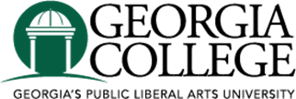

Graduate Research Grant Recipients 2017

Terrell S Johnson
“Kaolin Products as Prospective Tools for the Sorption of Biofilm-Forming Bacteria”

Alyssa Thompson
“Reduction of Proportions of Freshwater Diatoms during the Savannah Harbor
Expansion Project in Port Wentworth, GA”

Calabria Turner
“Politically Cyclical: Richard II and Machiavelli in Elizabethan England” and
“Embrace Your Femininity: Jessica Swale’s Nell Gwynn”

Merry Zohn
“Assessment of Diatom Movement and Species Composition in Relation to
Various Tide Levels on St. Simons Island, GA”

