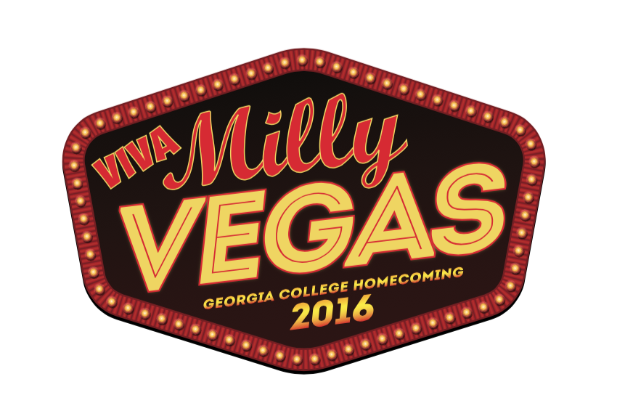

Viva Milly Vegas
Homecoming 2016
Trivia Poker Run

Questions for Thursday, Feb. 4, 2016

Answer the following questions at the designated locations to select a playing card from the deck. Complete a hand of five cards and turn the cards in to University Communications, 127 W. Hancock St., before 4 p.m. on the day of the contest. The player with the best hand of the day will win a pair of concert tickets to GC Jamfest 2016.

- The DEN: What is the name for the world’s largest mechanical neon sign – a giant cowboy that appears in Vegas?
- The Innovation Station: Aside from “Milly Vegas”, what is another nickname for Milledgeville that refers back it its historical significance in the state?
- The library circulation desk: At what Vegas hotel would you find a large bronze lion?
- Barnes & Noble at Georgia College: What river runs near Milledgeville?
- The Bobcat Card Office: What is the name of the theater at Caesar’s Palace in Vegas that has hosted acts such as Celine Dion, Britney Spears and Elton John?

