Student Disability Resource Center
Campus Box 123
Milledgeville, GA 31061
Phone 478-445-5931
Fax 478-445-1959
disability@gcsu.edu

Thank You for Being a Note-Taker!
You must commit to submission of notes at least once a week. The more notes you submit, the more service hours you’ll receive!

- How are you going to provide notes?
  - E-mail typed notes to: disability@gcsu.edu Please send attachments in PDF or Word format.
  - Scan notes using the scanner in the Library. Loose-leaf paper only.

- Please format each set of notes with a title page that includes:
  - Your name
  - Class that you are taking (ex: MKTG 3180)
  - Professor Name
  - Date
  - How many hours of notes you're sending for that particular class (If you’re sending in notes on Monday afternoon for a 3-credit-hour MWF class you would be submitting notes for 1 hour.)
This ensures that you are getting credit for your work and we know what has been turned in to our office.

- You will receive volunteer hours for each hour of notes provided.
  - Ex: MWF 8-8:50 = 3 hours per week that notes are taken.
  - Please scan and e-mail notes daily. When you send your e-mail to submit notes, please include how many hours of notes you're sending for that particular class.
  - Hours do not include test days or student presentations.
  - When you submit your notes to the Student Disability Resource Center we will tell you how many hours to log in to GIVE Pulse in order for you to get volunteer hours.
  - GIVE Pulse is located in Unify. Please watch the tutorial here before logging hours: https://youtu.be/nnXoPeHTsN4
  - When you add the verifier’s contact information you will type: Verifier’s Name: Tiffany Smith; Verifier’s Email: disability@gcsu.edu
  - You are taking notes for Note Takers-Disability Services

Note-Takers Form

Name_____________________________________________Date_______________GCID________________
Semester__________________________________ Class (circle one) FR SO JU SE
Bobcats Email____________________________________ Cell Phone______________________________
 | Course | Class Title | Professor  Last Name | Total Class Time/Day
 | Example:  MATH 2600  CRN 80000 | Example:  STATISTICS | Example:  STOVER | Example:  MWF 8-8:50
1
2
3
4
5
6
Method: Scanning Email/Typed
Please list only the courses where you will be taking notes for our office!

Student Disability Resource Center
Campus Box 123
Milledgeville, GA 31061
Phone 478-445-5931
Fax 478-445-1959
disability@gcsu.edu

Scanning Your Notes in the Library

Please format each set of notes with a title page that includes:
  - Your name
  - Class that you are taking (ex: MKTG 3180)
  - Professor Name
  - Date
This ensures that you are getting credit for your work and we know what has been turned in to our office.

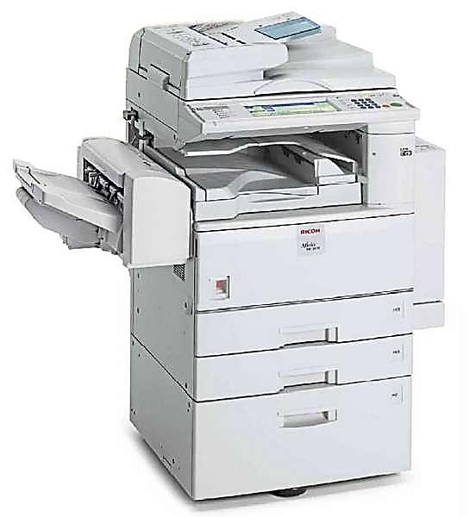
Scan to E-mail:
- Swipe Bobcat Card to activate function – No charges should be assessed
- Use the document feeder on top of the copier – see image to the right
- Place your notes face up and vertical, as if you’re reading them.
- If your notes are on both sides of the paper select 2-sided on the touch screen
- Select 1>2-sided and press OK
- Select the Send tab
- Select the E-mail option on the touch screen
- Select E-mail Address and manually enter disability@gcsu.edu
- Select OK
- Press the green Start button to begin scanning
- Select Done when finished

If we cannot read your notes or if they did not scan properly we will ask you to scan them again and resend.

