Black Bear | Human | Frog | Alligator | Dragonfly
Camel | Cave Bear | Chimpanzee | Crab | Dinosaur
Platypus | Giant Beaver | 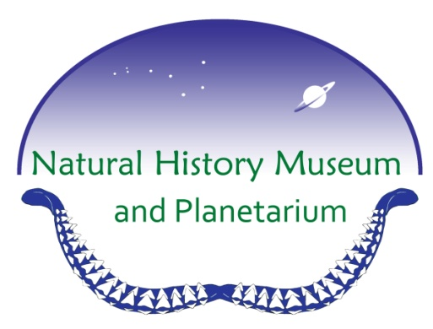 | Giant Bison | Gorilla
Ground Sloth | Komodo Dragon | Lemur | Mammoth | Megalodon
Pterodactyl | Oryx | Rhinoceros | Saber toothed cat | Starfish

Natural History Museum BINGO

Water Buffalo | Dragonfly | Trilobite | Giant Beaver | Terror Bird
Megalodon | T. rex | Mammoth | Starfish | Bontebok
Giant Bison | Saber Toothed Cat |  | Lemur | Cave Bear
Dragonfly | Rhinoceros | Ground Sloth | Frog | Alligator
Jellyfish | Coral | Camel | Oryx | Bobcat

Natural History Museum BINGO

Komodo Dragon | Alligator | Platypus | Saber Toothed Cat | Dinosaur
Frog | Lemur | Starfish | Mammoth | Giant Beaver
Human | Megalodon |  | Terror Bird | Gorilla
Black Bear | Harpy Eagle | Jellyfish | Two-toed Sloth | Oryx
Crab | Pterodactyl | Water Buffalo | Trilobite | Giant  Bison

Natural History Museum BINGO

