A Day in the Life of an American Slave
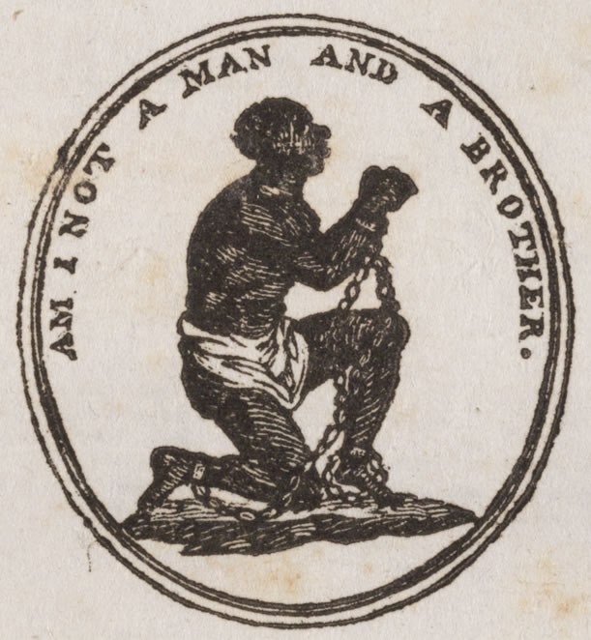

While the idea of owning another person may seem crazy to us today, it was an accepted custom in the United States up until the Civil War.
People played many different roles in order to make slavery happen. First, there were slave traders, men who worked in the business of buying and selling slaves. There were slave owners. These were usually wealthy white families, although poor white families and even some free black families also owned slaves. There were overseers. An overseer’s duties included making sure that all work was completed in the field. Finally, there were the slaves themselves. Slaves were divided into two categories: house slaves and field slaves. House slaves lived and worked in the “big house” with their white owners and tended to domestic duties such as cooking, cleaning, sewing, and caring for the children of the family. Field slaves lived in slave quarters a short distance from the house and they worked in the fields tending to crops. Both house and field slaves led very difficulty lives.

Visit this web site and see what a typical day would have been like for these people.
A Day in the Life of...

Discussion questions:
1. Who do you think has the most difficult set of daily activities? Why?
2. What differences do you see between the daily life of a house slave and of a field slave? Similarities?
3. How would you feel about having to work on a slave ship?
4. Do you think that the slave owner cares about his slaves?
5. If you were the field slave, would you have tried to run away with Tom? Do you think Tom was wise or foolish?

