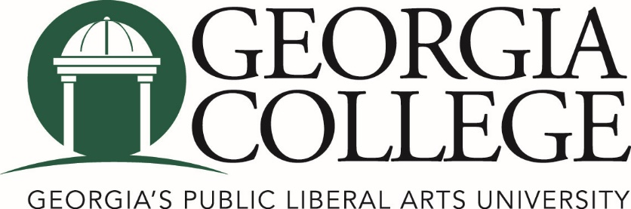

Mentored Undergraduate Research and Creative Endeavors Symposium Georgia College November 3, 2017

Agenda

Providing opportunities for faculty to learn from each other and from students about successes and barriers to MURACE that inform goals for sustainable and meaningful MURACE at GC

11:45 - Noon REFRESHMENTS & CHECK-IN TBA

Noon - 12:15 WELCOME & OVERVIEW:
Mentored Undergraduate Research &Creative Endeavors
and the GC Journeys Program, Jeanne Sewell, Interim Director
Of the Center for Teaching and Learning

12:15-12:45 SESSION I: MURACE UPDATES TBA
- GURC (Robin Lewis & Steven Jones)
- GC Research Conference (Steven Jones)
- NCUR (Kelly Massey & Dee Sams)
- COPLAC (Hasitha Magabaduge and Dee Sams)
- MURACE Faculty UR Community (Members of the Community)
      - CUR Enhanced Membership (Tsu-Ming Chiang)
      - Student Travel Funding (Steven Jones)
      - External Grants (Robin Lewis)
      - GC Library (Jolene Cole, Jeff Gainey, or Shaundra Walker)

12:45-1:30 SESSION II: BEST PRACTICES IN MENTORING UNDERGRADUATES IN RESEARCH

- High Impact Learning Through Mentored Research Opportunities (Karen Berman, Tsu-Ming Chiang, Dee Sams, and JF Yao)

1:30-1:40 BREAK TBA

1:40 – 2:15 SESSION III: STUDENT PANEL ON BENEFITS OF MURACE

- 1 (SCIENCE) - TBD
- 2 (ARTS AND HUMANITIES) - TBD
- 3 (PROFESSIONAL SCHOOLS) – Kate Butcher

2:15-3:30 BREAKOUT SESSION See room assignments
Breakout sessions are designed for participants to work with facilitators of the symposium sessions to take the first steps in creating action plans (individual course, department, division, etc.)
- The Wheel of Research the Pathway through the GC Journey (Dee Sams)
- Scaffolding UR across the Curriculum – Humanities, Social Sciences, Business, Education (Tsu-Ming Chiang)
- Scaffolding UR across the Curriculum – Creative Endeavors (Karen Berman)
- Scaffolding UR across the Curriculum – Sciences (Kalina Manoylov)

3:30 – 4:00 WRAP-UP TBA

Report Out – Action Plans from Breakout Session

