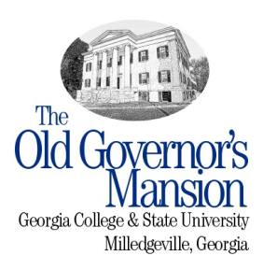

COLLECTIONS TOURS
THE OLD GOVERNOR’S MANSION

Collections Tours will be conducted from 11:00AM to 2:00PM Tuesday-Friday by appointment or through special arrangement.

COST: ADULTS $15
SENIORS $8
ADULT GROUPS $10
STUDENTS $4

FOCUS: The Collections Tour, hosted by the Mansion Curator, provides visitors with an opportunity to hear an in-depth discussion of the Mansion’s varied material and textile collections, the process of building the collection following the recent $9.5 million dollar restoration of the structure, and culminating in the methodologies employed in locating both original and period appropriate pieces and materials for display within the museum.

The program will center on specific rooms of the structure and if you have ever been interested in learning about antiques and the tenants of historic preservation, then this is a program that you don’t want to miss!

Reservations are required to participate and can be made by calling the Mansion offices at 478-445-4545. Reservations are due the day before each program.

