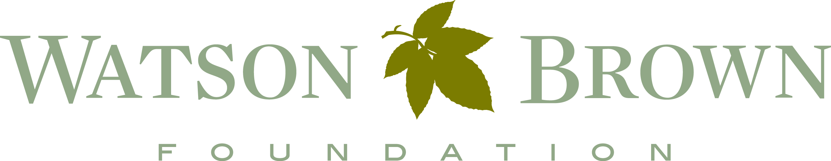

JUNIOR BOARD – Milledgeville Chapter
Grant Application

The Watson-Brown Foundation, Inc. supports historic preservation in part through its Junior Board, a group of local high school students whose exclusive mission is historic preservation. The Junior Board awards $30,000 in grants annually to historic preservation projects in select areas of Georgia and South Carolina.

The Junior Board primarily considers grants to organizations that are defined in Internal Revenue Code Sections 501(c)(3) and 509(a)(1), 509(a)(2) or 509(a)(3). They may consider grants to for-profit institutions. The Junior Board does not consider grants to individuals, for religious programs, for political or lobbying activities.

Eligible Counties: Projects must occur in one or more of the following counties –Bibb, Monroe, Twiggs, Wilkinson, Jones, Jasper, Morgan, Putnam, Baldwin, Hancock, and Washington.

Grants WILL NOT be considered for: projects that have been completed, general operating, or endowments. Only 1 application per organization will be accepted in any fiscal year.

Completed proposals must be RECEIVED IN OFFICE by March 16, 2018. Please clip together materials with a binder or paper clip; do not bind or staple materials. Grant notifications will be made by mid- late May and be paid out in June.

Mail proposals to:
WBF Junior Board of Trustees
Milledgeville Chapter
C/O Matthew S. Davis
Campus Box 092
Milledgeville, GA 31061
Or by email at matt.davis@gcsu.edu

Review Process. A Junior Board representative will contact the applicant for a site visit; these are generally conducted Monday through Friday, after 4:30pm or on Saturday. ALL funded projects are required to submit a final report, receipts, photos or other deliverables upon completion of the project.

If you have questions about a project or to receive an electronic copy of this application, please contact Matthew S. Davis, Junior Board Coordinator, 478-445-4545 or via email at matt.davis@gcsu.edu.
Grant Application
Cover Sheet

ORGANIZATION INFORMATION

Legal Name of Organization:______________________________________________
Organization Description: _______________________________________________
Address: _______________________________________________
_______________________________________________
Phone: __________________________
Website: __________________________
Contact Person: ________________________ Phone:___________________
Contact E-mail: __________________________
IRS Status (check one)
___ For profit ___ 501(c)____ ____509(a)_____
EIN Number, if applicable: _____________________________________
Type of Project:
Historic Structure Artifact Cemetery
Education Signage Archaeology
Research/Report Other_________________________________
Has the organization secured additional funding for this project? YES NO
If so, for what amount? $______________________
Do you plan to apply to the Watson-Brown Foundation Board this fiscal year? YES NO

What is your organization’s entire operating budget for the current fiscal year? ______________

Grant amount requested from the Junior Board in 2018: ______________________

I understand that by signing this application that everything represented here is accurate to the best of my knowledge. I also understand that by applying my organization agrees to host a site visit by Junior Board representatives during the review process.

Signature: __________________________________________________________

PROJECT BUDGET

Name of Organization: ____________________________________________________

Instructions:
Please attach bid sheets for services and materials, with costs for various project elements broken out individually on the bid (i.e., labor: $6000, replace siding $4000, paint $1200, reglaze windows $50); attach the contractor’s qualifications for work on a historic resource if relevant.

It is beneficial & accurate to show that the applicant organization is contributing man hours (salary or volunteer), supplies, or other in-kind costs to the project.
- volunteer labor can be used as a match at the federal rate of $23.56 per hour.
- in-kind supplies and services can be used as a match.
- the Federal mileage reimbursement is 53¢ per mile.

You may use an alternate budget format provided Applicant & Request amounts are clearly stated.

Junior Board Applicant Total for
Request Contribution Project
Project Staff Fees
(include staff, intern, _________________ _______________ $____________
and volunteer salaries
dedicated to this project)

Professional Services _________________ _______________ $____________
(such as contractors)

Supplies and Materials _________________ _______________ $____________
(such as mortar,
bricks, glass)

Equipment _________________ _______________ $____________
(such as backhoes)

Transportation _________________ _______________ $____________
(mileage reimbursement
related to project)

Postage and Printing _________________ _______________ $____________

Other
_________________ _________________ _______________ $____________
_________________ _________________ _______________ $____________
_________________ _________________ _______________ $____________
_________________ _________________ _______________ $____________

TOTALS Junior Board Applicant Total Project
Request Contribution Budget

_________________ _______________ $____________
(column total) (column total) (total across/down)

GRANT CHECKLIST – REQUIRED ELEMENTS

Cover Sheet: The cover sheet must be the first page of your application.

Contact Information: Provide the name & contact information for the person we need to contact about the project.

General Overview: BRIEFLY Describe your organization and the general purpose of the preservation project.

Project: Describe the preservation project; include: the location, duration, anticipated outcome, goals, how this project will benefit the community, and the organization’s qualifications to achieve this project. Be detailed.

Sustainability: If this project is ongoing how will it be sustained/funded/maintained into the future?

Secured Funding: Include information about funding already secured for this project, including volunteer labor.

Bids: Acquire at least 1 bid for the project. The contractor MUST break out elements of the project with the costs if there are multiple project elements (i.e., labor, replace siding, paint, reglaze windows).

Project Budget: Please use our budget format. Check your math.

OPTIONAL

Contractor Qualifications: If appropriate, please include the contractor’s qualifications to perform work on a historic structure. Weight is given to contractors that have prior experience doing appropriate work on historic structures.

Photographs: Include no more than 5 images that relate to the project. These may be emailed separately.

Campus Box 092
Milledgeville, GA 31061

