SHHP Graduate Handbook
2016-17

SHHP Graduate Programs

Georgia College & State University

CBX 112

Milledgeville, GA 31061 (478) 445-4072

Fax (478) 445-4074 gcsu.edu/health/shhp

M.S. in Health & Human Performance:
Human Performance
Health Promotion

MAT in Kinesiology:
Physical Education

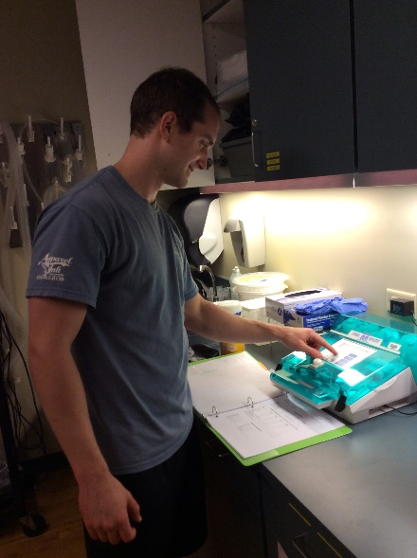

Contents
Section I—Administration 5
Section II—Admission 6
M.S. in HHP: Human Performance Admission Criteria 6
M.S. in HHP: Health Promotion Admission Criteria 6
MAT in Kinesiology: Physical Education Admission Prerequisites & Criteria 7
Admission Decision Procedures 8
Transfer of Graduate Program and Transfer Credits 8
Section III—Performance, Registration and Program of Study 8
Performance of Graduate Students 8
Registration of Graduate Students 8
Program of Study 9
Section IV—Graduate Assistants 10
Appendix A—How to Register for Classes Through PAWS 14
Appendix B – ADP Registration 17
Appendix C – Thesis and Project forms 21
Appendix D: Academic Writing Resources 25

PREFACE

About SHHP Handbook

The Handbook contains the rules, policies, and guidelines applicable to SHHP graduate students within the College of Health Sciences. These rules, policies, and guidelines are reviewed by the Director/Coordinator of the School of Health and Human Performance. It is regularly updated through the year as the Graduate Coordinator, Council, and or Academic Dean makes or revises rules and guidelines.

The School of Health and Human Performance offers two distinctly different master’s degrees. The Master of Science (M.S.) in Health and Human Performance offers students a concentration in either Health Promotion or Human Performance. This degree has a sequenced curriculum that provides opportunities for scholarly investigation in professionally relevant areas. A thesis option or a significant project in a relevant professional setting is also available for more in-depth research experience.
Candidates for the M.S. in Health and Human Performance may pursue the degree while remaining in a professional employment position. Once finished with the program, graduates frequently utilize their newly acquired knowledge and skills to improve job performance and to improve the quality of services to clients. Candidates may also decide to pursue an advanced degree as a means to make a career change or to seek a new position commensurate with a master’s degree.
The program requires 36 semester hours of graduate course work, and is designed as a two-year, full-time experience. Students may apply to begin the program in summer, spring, or fall. Each student is guided through the program of study by a professor skilled in advising, supervising, and mentoring.
The Master of Arts in Teaching (M.A.T.) degree in Kinesiology/Physical Education is the second master’s degree. It provides initial teacher preparation for qualified candidates who hold a bachelor's degree from a regionally accredited institution in a related discipline such as Kinesiology, Exercise Science, Health Promotion, Outdoor Education, Human Performance, etc. The degree program is designed for college graduates whose undergraduate degrees did not include coursework or learning experiences that previously certified them as a P-12 teacher. Successful completion of the M.A.T. program leads to a T-5 Georgia Teacher Certification in Health and Physical Education.
The program requires 36 semester hours of graduate course work, and is designed as a one-year, full-time experience, which ideally begins in the summer semester and is completed during the following fall and spring semesters. The M.A.T. Physical Education degree is offered in a cohort model. Teacher candidates enter together as a group. They take courses and complete field activities over a specified period of time. Each cohort group of candidates is guided during the period of study by a professor skilled in advising, supervising, and implementing best teaching practices.

Section I—Administration

The Graduate Programs within SHHP are governed by the following offices:

Graduate Coordinator. The Director of the School of Health and Human Performance occupies the office of graduate coordinator. The graduate coordinator provides overall academic leadership, develops and implements program policies, represents the interest of the program to the campus and GC administrators, and may call and preside at meetings of the program faculty. The Graduate Coordinator approves/denies student petitions. The Graduate Coordinator recruits and admits students in the SHHP graduate programs.

Lisa Griffin, Director and Professor
EdD, Physical Education-Teacher Education, West Virginia University
478-445-4072
lisa.griffin@gcsu.edu

Program Coordinators. SHHP Program Coordinators recruit and advise students in the graduate degree program. The program coordinator provides overall coordination of graduate activities within the program. The Program Coordinator is the first point of contact for student petitions. In addition, the program coordinators generally assist in the recommendations for admissions, changes to programs of study, and serve on graduate committees.

Human Performance:
Mike Martino, Professor - Exercise Science
PhD, Exercise Physiology, University of Alabama
478-445-6987
mike.martino@gcsu.edu

Health Promotion:
Barbara Funke, Professor - Public Health
PhD, Health Education, Pennsylvania State University
478-445-1780
barbara.funke@gcsu.edu

MAT in Kinesiology: Physical Education
Kevin Hunt, Assistant Professor - Physical Education
PhD, Physical Education Teacher Education, University of South Carolina
478-445-3926
kevin.hunt@gcsu.edu

Section II—Admission

General Information

Joint Responsibility for Admission. The admission of students into SHHP graduate programs is the joint responsibility of the Graduate Coordinator and the Graduate Admissions Office. However, the Graduate Coordinator has the final authority for making admission decisions. The Graduate Admissions Office receives and processes the application.

Application Deadlines. All prospective students should submit a completed application for admission and all supporting documents by the priority deadline. Please refer to graduate website or the Office of Graduate Studies for more information.
- Fall – July 15th
- Spring – November 15th
- Summer – April 15th

Application Fee. Graduate School applicants are required to pay a nonrefundable application fee. Application fees are waived for graduates of Georgia College.

M.S. in HHP: Human Performance Admission Criteria
The following are elements used to determine eligibility for regular admission:
- Minimum overall undergraduate GPA of 2.75
- Successful completion of an undergraduate statistics course
- Successful completion of Human Anatomy & Physiology or two integrated courses in Anatomy & Physiology
- Submit a letter of application indicating why you have chosen a career in human performance or health promotion and how the program of study meets your career goals
- Names and contact information for 3 professional references
- Provide a current resume'; copies of any relevant, current training certificates or certification cards
- Students applying to the M.S. in Human Performance must take the GRE or MAT exam. Official scores (sent by the testing center) are sent directly to the office of graduate admissions. GRE (minimum score 297) or Miller's Analogy Test (minimum score 385). Scores will be examined holistically with the other admission requirements on an individual basis.
- Documentation required by specific program areas may be sent by email attachment directly to the office of graduate admissions, toyia.barnes@gcsu.edu or by regular mail to the School of Health and Human Performance (attn: Graduate Studies).

M.S. in HHP: Health Promotion Admission Criteria
The following are elements used to determine eligibility for regular admission:
- Minimum overall undergraduate GPA of 2.75
- Successful completion of an undergraduate statistics course
- Submit a letter of application indicating why you have chosen a career in human performance or health promotion and how the program of study meets your career goals
- Names and contact information for 3 professional references
- Provide a current resume'; copies of any relevant, current training certificates or certification cards
- Students applying to the M.S. in Human Performance must take the GRE or MAT exam. Official scores (sent by the testing center) are sent directly to the office of graduate admissions. GRE (minimum score 297) or Miller's Analogy Test (minimum score 385). Scores will be examined holistically with the other admission requirements on an individual basis.
- Documentation required by specific program areas may be sent by email attachment directly to the office of graduate admissions, toyia.barnes@gcsu.edu or by regular mail to the School of Health and Human Performance (attn: Graduate Studies).

MAT in Kinesiology: Physical Education Admission Prerequisites & Criteria

Admission Criteria.
- Letter of application indicating why you have chosen a career in teaching physical education.
- Your teaching or professional philosophy, and how the program of study you are applying will meet your career goals;
- Current resume; copies of any relevant, current training certificates or certification cards;
- Names, phone numbers and email addresses of at least three references;
- Create a MyPSC account and confirm Georgia College as the program provider found at mypsc.gapsc.org. Georgia College will submit these forms to the Georgia Professional Standards Commission (PSC) to request a Pre-Service Certificate. The PSC does not charge a fee for these forms, which give the PSC permission to perform a background check.
- Complete the Educator Ethics for Program Entry GACE 350 found at http://gace.ets.org/ethics.
- SAT, ACT, Or GRE scores must meet the following minimum requirements or you must take and successfully pass the GACE Program Admission Assessment (Basic Skills) (200, 201, & 202) with a minim score of 250 on each of the three sections:
  - SAT- minimum required score= 1000 (with no minimum verbal score or math required.) The composite score is obtained by adding the Verbal and Math scores. Candidates must take both the Verbal and the Math sections of the test. Note: You can use the verbal portion of the SAT from one testing session and add it to the Math portion from another testing session in order to exempt the GACE Basic Assessment.
  - ACT- minimum score= 43 (English score + Math Score) Candidates must take both the English and Math sections of the test.
  - GRE & MAT- GRE (minimum score 297) or Miller's Analogy Test (minimum score 385). Scores will be examined holistically with the other admission requirements on an individual basis.
- Candidates for the MAT PE Program must also complete the Pre-Service Application Package. The affidavit for Verification of Legal Presence (included in the packet) must be completed with a notary public.
- A copy of the identification document (usually a GA driver’s license) also needs to be included with the other completed materials in the packet.

Admission Prerequisites.
- GCSU students who have earned the PE minor have satisfied all prerequisite requirements.
- GCSU students who have NOT earned the PE minor, or applicants from other institutions, must satisfy the following:
  - Required 15 hours of coursework:
    - Behavioral Statistics, Measurement & Evaluation, or Research Methodology.
    - Personal Health and Fitness, Health/Exercise Promotion, Exercise Leadership, or a similar in-depth Fitness/Wellness course.
    - Anatomy, Structural Kinesiology, or a similar Anatomical Kinesiology/Movement analysis course.
    - Motor Behavior, Motor Learning, Motor Control, or a similar integrated course in Psychomotor Development & Learning.
    - Skill Analysis, Coaching Course with a certification or licensure, Collegiate Coaching or Playing experience.
  - Required 3 hours of elective coursework
- Exercise Physiology.
- Exercise Biochemistry.
- Prevention and Care.
- Developmental Psychology or Human Development.
- Strength & Conditioning,
- Biomechanics.
- Exercise Testing.
- Exercise Prescription.
- Outdoor Education Group Development.
- Outdoor Education Living Skills
  - First Aid/CPR certification must be current, and ARC or AHA endorsed.

Admission Decision Procedures

Admit. If the Graduate Coordinator recommends admission as a regular student and if the applicant meets minimum Graduate School admission criteria, the admissions office notifies the applicant of admission by letter.

Denial of Admission. If the Graduate Coordinator recommends denial of admission, the admissions office notifies the applicant of that decision by letter.

Deferment of Admission. A student's registration is automatically canceled when he/she does not enroll for the semester or summer session for which he/she received admission. Any applicant wishing to defer the admission date must submit a written request to the graduate admissions office. Both the graduate admission’s office and the graduate coordinator must approve the request. The maximum time that a student may be granted a deferral is one year. After one year, a student must re-apply to the program. All application material becomes the property of Georgia College and will not be returned to the applicant or forwarded to another institution.

Transfer of Graduate Program and Transfer Credits

Students may transfer from one graduate program to another by completing the Request for Transfer of Graduate Program form available online. This form requires the approval of the advisor in the receiving program and the signed acknowledgment of the Graduate Coordinator in the current program. Up to 9 semester hours of graduate coursework with grades of B or better may be accepted from other institutions at the discretion of the Graduate Coordinator and the advisor.

Section III—Performance, Registration and Program of Study

Performance of Graduate Students

Grading Policy. A = Excellent B = Average C = Poor, but passing D – F = Failure

Performance. To receive a master’s degree, a student must have a grade point average of at least a 3.0 on a 4-point scale in his or her graduate program of study. A graduate student will be placed on graduate academic probation if the student's institutional graduate grade point average falls below a 3.00 at any point during his or her graduate studies. A graduate student will be dismissed if the student is placed on academic probation for more than one semester, receives more than one C during his or her graduate studies, or fails to comply with policy, procedures, and expectations as defined in current versions of the Graduate Student Handbook.

Reinstatement. A student who has been dismissed from the graduate program may petition the graduate coordinator for reinstatement after 12 months from the original date of dismissal. If the petition is approved, the Graduate Coordinator must submit the student’s petition to the Graduate Admissions Office for review.

Registration of Graduate Students

Registration. Full-time enrollment at the graduate level requires a minimum of nine graduate semester credits in both the fall and spring semesters. Six hours is considered full-time during the summer session. Prospective graduate assistants should refer to the section on graduate assistantships in this handbook for enrollment requirements. Students on financial aid must consult with the Office of Financial Aid for enrollment requirements mandated by their award programs (http://www.gcsu.edu/financialaid). Graduate students desiring graduate credit must enroll for the graduate level component of a course (i.e., 5000-6000 classes).

Registration Process. Once registration information is received, students are required to consult their advisor about course selection and lifting advisor hold.

New Students. Please see registration example below in Appendix A

International Students. New international students initiate registration by reporting to the Office of International Education Center before visiting the Graduate School.

Former Students. Students who have not been enrolled in the Graduate School for a year or more should contact the Graduate Admissions Office about reenrollment procedures (http://www.gcsu.edu/admissions/graduate).

Program of Study
Program of Study (POS). The graduate program of study is the listing of courses agreed upon between the student and the graduate advisor of that program. The courses listed must satisfy the course requirements prescribed in the Graduate Catalog. The student’s adviser will provide guidance in completing this requirement. Students can also refer to your DegreeWorks located in PAWS. Your most recent POS form can be found below.

- Health Promotion
- Human Performance
- MAT – Physical Education

Thesis/Project. Students in the M.S. in Human Performance can select either the thesis or project option by the end of the semester in which they complete eighteen (18) credit hours. Students may elect to change from the thesis to the project option up to and during the semester in which twenty-seven (27) credit hours are completed.

*The M.S. in Health Promotion is 36 hours of online courses, but students may opt to complete a thesis or project. If so, contact your major advisor.

The thesis or project will serve as each master's student's final evaluation. This is an individual process occurring throughout the master’s program with a culmination at the end of his or her program. This evaluation process is defined as satisfactory demonstration of mastery of subject matter in the graduate student's area of interest. This demonstration is monitored and documented by the student's Graduate Committee. Each Graduate Committee may establish time limits for the completion of its master’s.

Thesis Option. The thesis is a formal research study completed by the student under the supervision and guidance of a Graduate Committee. Students will select a Graduate Committee that will include a minimum of three (and not more than five) members on the committee. A majority of members on the committee will be faculty from SHHP. One committee member, having graduate faculty status, will serve as committee chair. One committee member shall be from outside the specialization area: in SHHP; a relevant external department at GC; or a relevant professional setting. Students electing this option must be prepared to be self-directed and work independently. Students who select the master's thesis option will complete six credit hours of thesis work (KINS 6873), registering for three hours of thesis during two consecutive semesters or six hours during one semester. Students who do not successfully complete the thesis in six credit hours will continue to register for an additional one (1) credit hour of thesis work (KINS 6873) in subsequent semesters until the thesis is completed. Graduate students must be enrolled in the graduate program to work with a faculty and use GC facilities.

Thesis Defense. A final draft of the thesis is submitted to the student's Graduate Committee at least two weeks prior to the thesis defense. Theses defenses are open to university faculty, students, and the public. The defense includes an oral presentation of the research (normally 20-30 minutes) followed by a period in which the student responds to questions from the committee and the audience. The committee will deliberate and decide, by simple majority, to accept as is, accept with revisions, or not accept the thesis. If the thesis is not accepted, the student will revise the thesis and convene a follow-up defense. One follow-up defense is permitted. Students who are unsuccessful on the follow-up defense must repeat KINS 6873.

Project Option. Students who select the master's project option will complete KINS 6972 and a minimum of one (1) elective that is approved by the student's graduate advisor in conjunction with the project committee chair.

Students will select a Graduate Committee that will include a minimum of three members on the committee. A majority of members on the committee will be faculty from SHHP. One committee member, having graduate faculty status, will serve as committee chair. One committee member may be from outside the specialization area and may be: in SHHP; a relevant external department at GC; or a relevant professional setting.

The project is a capstone experience that leads to professional growth related to the students’ career goals. Examples of projects may include, but are not limited to:
- An extensive, focused literature review;
- Case study;
- Piloted curriculum development or revisions;
- Piloted instructional technology;
- Program or facility development;
- Administrative or instructional policy and procedure manual.

Students must submit a written proposal for the project to their committee for approval.
Project Defense. The defense of the project will be a formal presentation in a format appropriate to the project. Formats may include, but are not limited to, a formal oral presentation, conference presentation, or program implementation. Following the defense, the committee will deliberate and will decide, by simple majority, to accept as is, accept with revisions, or decline/not accept the project. If the project is not accepted, the student must revise the project and convene another defense. Students who are unsuccessful on the first attempt may repeat the defense once. Students who are unsuccessful on the follow-up defense must repeat KINS 6873.

Graduation Requirements. To qualify for a graduate degree at Georgia College (GC), it is the student's responsibility to know and satisfy the following requirements:
- Fulfill the departmental requirements for the degree chosen. These requirements are described in the degree programs section of the graduate catalog of the year in which the student entered GC.
- Fill out the Graduate Graduation Application (pdf) by the dates indicated in the Official University Calendar (Academic Calendar) for the term the student plans to graduate. This application is submitted to the Office of the Registrar (107 Parks Hall) by the applicant. A graduation fee will be assessed (upper left hand corner of application).
- A student planning to use transfer work to qualify for a degree must have official transcripts submitted to the Office of the Registrar no later than the beginning of the semester immediately preceding graduation exercises.
- The degree program coordinator approves the applicant's plan to graduate.
- Any student who is unable to complete final requirements for graduation after formally applying for a degree will be ineligible to graduate. Students will be notified if graduation requirements are not completed and will be required to resubmit the application for graduation for a future semester.
- Students may graduate in absentia provided they submit written notice to the Office of the Registrar of their intention to do so at least seven days before the date of commencement.
- Georgia College reserves the right to refuse to forward transcripts for any student who has an unsatisfactory conduct record or who is in financial arrears to the University.
- Students enrolled in degree programs requiring a thesis or final research paper must deposit the approved unbound original and one bound copy of their work in the Library and Instructional Technology Center. Other copies of the thesis or final research paper may be required by the department in which the major work has been done.

Review Appendices B for Thesis/Project forms

Section IV—Graduate Assistants

A graduate assistantship (GA) is an assignment of employment offered to a graduate student to assist a professor and the academic unit in the delivery of classroom and laboratory instruction, research, and other departmental needs. These positions help facilitate the student’s growth, both professionally and developmentally, through work experience in a supervised setting. Graduate assistantships are available in the graduate programs across campus. Assistantships are normally offered to graduate students who possess exceptional academic skills.

Qualifications. In order to receive an assistantship position, you must have regular admission to your program, be enrolled in at least 6 graduate hours per semester, and be in academic good standing. If your grade point average falls below 3.0 (academic warning) you will have one semester to improve and return to academic good standing before termination of the assistantship. Should you fail to return to good standing after one semester or receive academic exclusion, your assistantship will be terminated at once.
No student will be eligible to receive an assistantship position beyond 24 months or the completion of one graduate degree.

Appointment Procedures. Available graduate assistantships may be found on the Graduate College website at https://www.gcsujobs.com/. Available assistantships will be posted and updated accordingly throughout the academic year. Student inquiries regarding specific positions should be directed to student’s graduate advisor. Additionally, it is the responsibility of the applicant to pursue possible positions throughout the University. The GA appointment process is standard, regardless of the student’s status, residential or international. Confirmation of a student’s appointment is dependent upon the following process:
    - Students apply at gcsujobs.com
    - A list of eligible applicants is forwarded to assistant supervisors.
    - Chosen applicants will require interviewing and/or review of credentials to evaluate appropriate placement.
    - Upon supervisor’s notification, chosen applicants will receive an offer letter and HR documentation by email. Signed original documents must be returned to SHHP administrative offices.
      - Return by mail to: Georgia College, CBX 112, Milledgeville, Georgia 31061
      - Return in person: 104 Parks Memorial – 210 W. Montgomery Street
    - The applicant must sign a contract which outlines the duration of the graduate assistantship, the stipend amount, hours associated with the assistantship, and a brief description of the duties to be performed. After signing the contract, all GAs are required to fill out Human Resources paperwork. Failure to complete HR forms prior to the start of the semester can result in late payment for that month. Additionally, the student must complete all additional paperwork to gain appropriate computer access and/or keys the graduate assistantship may require; the applicant will be advised by the assistant supervisor if any is required.
    - SHHP views the orientation as an integral part of the graduate assistantship program; attending orientation is a prerequisite to holding a graduate assistantship. If an applicant accepts a graduate assistantship for fall or summer, they must attend the Graduate Assistant SHHP and HR Orientation offered in the fall semester. New GAs in the spring semester will have a spring session. At the orientation, the SHHP Support Services will not only reiterate expectations, but also help students transition into their role as a GA.

Graduate Assistant Roles. Applicants selected to hold a graduate assistantship may work only within their contracted department; multiple graduate assistantships within one time period are not acceptable. Additionally, GAs may not hold multiple on-campus roles, i.e. GA and student worker, during the same semester term.

Compensation. All students granted a graduate assistantship receive a tuition waiver. This waiver will pay all tuition costs for a maximum of twelve (12) credit hours per semester. All fees are the responsibility of the student. Generally speaking, students holding an academic assistantship will receive a stipend of $4,630 annually, $2,315 per semester. Students are responsible for paying all fees and purchasing books. However, the amount of the stipend awarded may vary depending on the nature of the GA position, effective start date, and the number of hours worked by the student each week. Non-academic graduate assistantships are awarded with varied stipend amounts, according to responsibilities and expectations for individual positions. Obligations and payment are explicitly discussed prior to a contract agreement. These positions may also be affected by the length of the contract and responsibilities associated with the appointment. Graduate Assistants will be paid one fourth of their stipend on each of the payroll dates determined by the Office of Fiscal Services. Please note, fall students will receive their first paycheck at the end of September. Tuition for summer and Maymester courses or workshops are not covered by your assistantship.

Hours. Graduate assistants are required to work an average of 20 hours per week for a total 300 hours during the fall and spring semesters. Your work schedule starts on the first day of classes and runs until the last day of final exams.

Timesheets. Documentation of time worked is required monthly. GAs should complete the appropriate timesheet using the ADP system. Students will register for ADP during their Human Resources orientation. Please see Appendix B below for ADP registration instructions.

Health Insurance. All graduate assistants are required to have health insurance. Students who are not covered by a policy held by a parent, spouse, company or organization on the approved waiver list (Organizations and Agencies Approved Waivers) or if the policy does not meet the minimum standards, must purchase the USG SHIP policy. Students with individual or association plans will not be considered for a waiver. For additional detailed information regarding the Student Health Insurance program, visit the University System of Georgia Web site.

Appointment Terms and Eligibility for Reappointment. GA appointments should be contracted for one or both semesters of a nine (9) month academic year. To ensure timely consideration, students seeking a graduate assistantship should complete the online application no later than May 1 for the fall semester or November 1 for a spring assistantship. GA applications are valid for one academic year; therefore, returning graduate assistants must complete a reappointment form for the next academic year. Graduate assistant appointment is contingent upon maintenance of academic good standing as defined in the Graduate Catalog; completion of at least six hours of graduate course work per semester; and satisfactory performance each semester in your assistantship assignment, as determined by your supervisor.
Resignation. Those leaving a GA appointment before the contractual end date must provide their supervisor and Graduate Coordinator written notice of their resignation. An email with a read-receipt request is acceptable or a properly stamped and addressed letter to the recipients. The written notice must contain the following: (1) name; (2) reason for resignation; and (3) the effective date of resignation. Graduate Coordinator notification should be sent to Jordanne.cary@gcsu.edu or mailed directly to the GC –Campus Box 112 through the US Postal Service. Once SHHP receives a formal resignation from a GA, a copy of the written resignation should be sent to Graduate Admissions. The vacant graduate assistantship may not be refilled until proper notification is received and processed by SHHP. GAs who terminate their graduate enrollment during the academic year, forfeit their graduate assistantship and void their current contract. In these cases, the student may be eligible for future assistantships if they meet the following procedures: (1) GA leaves position on good terms; (2) they provide a written resignation describing the nature of their departure; (3) they have a minimum cumulative GPA of 3.0; and (4) they enroll in the minimum number of graduate credit hours required.
Termination. Unsatisfactory performance of assigned GA duties will be grounds for termination of the GA appointment at the discretion of the supervisor and graduate coordinator. Students terminated from a GA appointment are considered ineligible for future positions within SHHP. Before termination is final, the GA supervisor or graduate coordinator will provide a written explanation of the unsatisfactory performance and outline their expectations for the GA moving forward. If after a period of two weeks, the GA has not satisfied the written expectations, the GA may be terminated. Termination of a GA may be immediate in the following circumstances: (1) The GA misses at least 50% of their scheduled work dates within first two weeks of the assistantship. Under this circumstance, GA termination is left to the discretion of the immediate supervisor and the ability of the GA to make-up hours within the parameters set forth by the supervisor; (2) if it is determined the student committed sexual harassment against another student, faculty, or staff as defined by university policy; (3) the overall GPA of the student falls below 3.0; (4) if it is determined the student committed an act of academic misconduct, including but not limited to, cheating, plagiarism, or falsification of data; (5) dishonesty, insubordination, or other conduct reflecting unfavorably upon the reputation of the University; (6) improperly disclosing information protected under FERPA; or (7) violation of Student Code of Conduct, state or federal law.
Ramifications of Termination/Resignation. In the event of resignation or termination, the GA will be sent a bill for the pro-rated amount of tuition benefits provided to the student that semester. Departments are responsible for sending all documentation of deficient performance and a completed Graduate Assistant Resignation/Termination letter to GC Business office. When an assignment is terminated, the College’s payroll administrator (Julie Collis), Human Resources and Payroll office should be contacted.
Expectations of Graduate Assistants Image
Appearance. As a member of the Georgia College, appearance is a reflection on the institution. Therefore, GAs are expected to dress appropriately and maintain proper hygiene for their appointment. What is considered appropriate may depend on the type of graduate assistantship and the nature of work in a given circumstance. However, the following type of clothing is not appropriate: (1) spaghetti straps, halter tops, strapless, or tank tops; (2) clothing with any kind of stains or holes; (3) shorts or skirts well above the knee; (4) pants that show underwear; (5) apparel from other institutions; and (6) visible tattoos/piercings.
Etiquette. Proper manners and social behavior is mandatory for all GAs. Remember to shake hands when meeting new coworkers, peers, or guests. In addition, utilize titles such as ―Mr.‖, ―Ms.‖, or ―Dr.‖, and withhold overly personal conversations/information in the workplace.
Communication. Poor communication can create problems amongst co-workers and guests alike. It is imperative to communicate clearly concisely, and frequently with your major professor. Please consider the following tips: (1) verbal—speak with a positive tone, speak clearly and at an appropriate level; (2) non-verbal—be aware of your body language and personal hygiene; and (3) written—aim to be concise and remember to proofread everything. Social media is another growing form of communication. Facebook, Twitter, and other social media sites are forbidden during work hours. Additionally, no negative posts should be made regarding GC while employed by the institution.
Responsibility. If granted a graduate assistantship, one will enter a professional workplace. As such, it is important GAs are accountable for individual actions, decisions, and choices within the work setting. Be aware that generating trust among coworkers is important. If you claim you will complete something, be sure it is completed well and in a timely manner.
Confidentiality. GAs are, in some capacity, privy to sensitive student and personnel information. Therefore, all non-directory information outlined in the Family Educational Rights and Privacy Act (FERPA) is expected to be protected and only discussed in the appropriate workplace setting. Violations to FERPA are grounds for immediate termination. Additionally, it is inappropriate to discuss university personnel issues with students.
Competency. All GAs will be provided training for their position but it is the responsibility of the GA to acquire competency with assigned tasks. Questions and note-taking are encouraged for accurate training results.
Relationships. Demonstrating a level of respect to any individual located on the GC campus is essential.

Appendix A—How to Register for Classes Through PAWS

Appendix A
1. Open your web browser (e.g. Internet Explorer, Chrome, Firefox, Safari) and in the address bar, type in www.paws.gcsu.edu
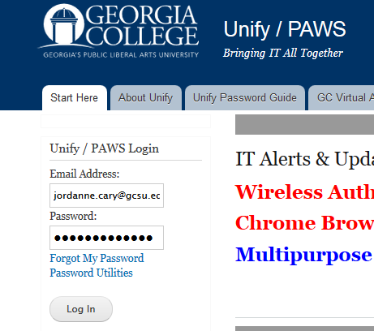
2. Log in using your Georgia College email address and your password (if this is your first time, your password will be your birthdate in MMDDYY format)

3. Next, click on the PAWS icon to enter the PAWS site

4. From the Main Menu you will click on Student Services

5. From Student Services click on Registration.

7. From the Registration Term page, select a term. Then, click submit.

8. From the Registration Term page, select Add or Drop Classes

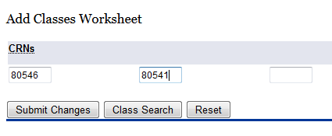
9. On the Add or Drop Classes page, type in the CRNs associated with the courses you want to take. Then, select Submit Changes.

10. If you are unsure what your courses CRN is, Click on Return to Menu 3 times to return to the Main Menu

1

2

3

12. From the GC Class Schedule Choices page, choose the term and subject, then click
Submit Choices.

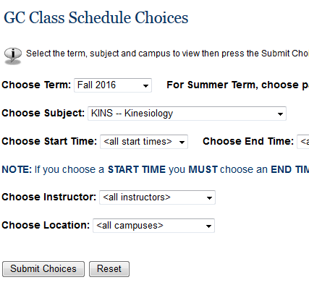

13. Scroll through the courses until you find the one you want. Write down the CRN number to add to
your worksheet later. Continue this process until you find all the courses you need.

Appendix B – ADP Registration
Appendix B
Overview. Before you can access any ADP web applications, you will need to register as an ADP Portal user and create a Password. The ADP web applications allow you to access your electronic time card (when applicable), enroll in benefits (when applicable), view your pay statements, view your W-2s, and much more. Once you receive confirmation from HR that your hiring process is complete, you will follow these instructions to create your account. To create your account, you will need:
- Your Social Security Number (SSN)
- USG Passcode

To obtain the USG Passcode, contact the USG Shared Services Center (SSC) toll free at (855) 2142644 or email us at helpdesk@ssc.usg.edu.
For additional assistance, you may view a video demonstration provided by ADP at
https://support.adp.com/netsecure/pages/pub/clientuser/1.0/ssr/ADP_Employee_Self_Service_Regi stration.htm.htm.

Needs Assistance. If you need assistance with these instructions, receive an error message at any step in the process or have any concerns once you are logged in, please contact our Shared Services Center (SSC) Customer Support team for assistance. Our normal business hours are Monday through Friday 8:00 A.M. – 5:00 P.M. except holidays. You can call us toll free at (855) 214-2644 or email us at helpdesk@ssc.usg.edu.

Instructions.
1. Access the ADP Portal at https://portal.adp.com
a) Under First Time User, click CREATE ACCOUNT.

2. Begin Registration
2.1. Find Your Record
- Enter the Registration Code you obtained from the Shared Services
Center in the Registration Code field.
- Click Go.
2.2. Verify Identity
- If another organization other than “University System of Georgia” is on the screen, click Start over.  - Enter your personal information to verify your identity. You will need your Social Security Number (SSN).  - Enter your First name.  - Enter your Last name.  - Enter your full SSN, EIN, or ITIN (You will need to enter twice to confirm.)  - Click Confirm. | 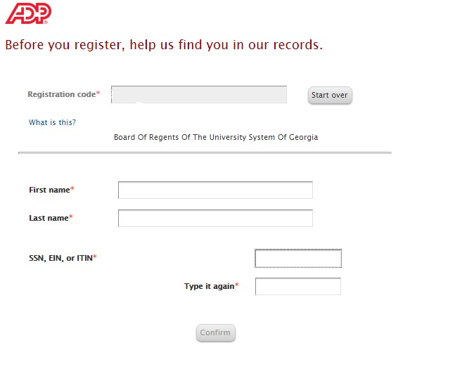
- Click Register now.
- If your name is not retrieved, verify the information you entered and click Confirm again.
- If you are still unable to retrieve your information, contact our Shared Services Center (SSC) Customer Support team at (478) 240-6500 or email us at usgdatahelp@ssc.usg.edu for assistance.

3. Register for ADP Services
3.1. Enter Contact Information
a) ADP uses this information to email your activation code to you. The contact information is also used to send temporary passwords if you need to reset your password.

Note: For notifications, employees should use the email address furnished by their institution for their “Work” email address.

3.2. Create Password
- Your User ID will be displayed on the screen.  - Create your Password. The password must be at least eight (8) characters long, contain at least one (1) letter and one (1) number, and is case sensitive.  - Enter the password you created in the Confirm Password field. | 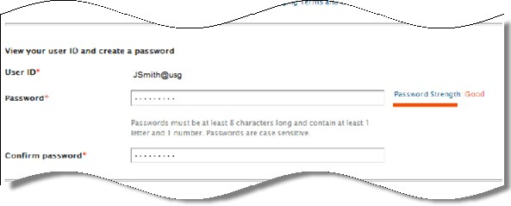
3.3. Select Security Questions and Answers
- To protect your account, select three security questions and answers. Your answers are not case sensitive and must be at least two (2) alphanumeric characters.  Note: If you forget your user ID or password, you will be required to answer these questions to confirm your identity.  - Click Register now. | 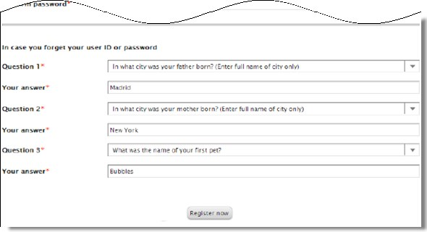
3.4. Registration Complete
a) Respond to the message within 24 hours to activate your email and/or mobile phone.

Note: If you do not activate your information, you will not be able to receive notifications (including temporary passwords) using the contact information you entered on step 3.1.

- You may click ADP Security
Management (Netsecure) to add ADP services available to you. To add ADP Enterprise eTIME, refer to job tool, EMP-CS-2005JT ADP Portal – Add or Re-Add eTIME.

Note: Enterprise eTIME is the Time and Labor Management system used by employees to:
  - Record and review hours worked
  - View exception time accrual balances (vacation, sick, and floating holiday)
  - Request or cancel time off
  - Request or cancel leave time
- To log in to your ADP Self Service account, click Self Service.

4. Activate Your Email Address and/or Mobile Phone
Note: You must activate your email address and/or mobile phone number within 24 hours.
4.1. Activate Email Address
- Once your registration is complete, you will receive an email from “ADP Generated Message…” providing instructions to activate your email address.  - Follow the instructions contained in the email. | 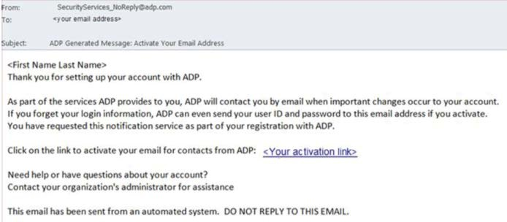
4.2. Activate Mobile Phone
- Once your registration is complete, you will receive a text message from ADP.  - Reply with the code in the text message to activate your mobile number. Note: In the United States, the message will come from sender “90206”. | 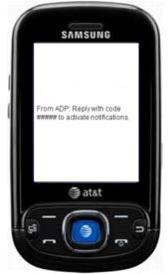

Task Complete

Appendix C – Thesis and Project forms
Appendix C

Georgia College
College of Health Sciences
School of Health and Human Performance

KINS 6863: Master’s Thesis in Kinesiology I

Students will develop a schedule for the successful completion of the thesis with the Committee Chair. Successful completion of KINS 6863: Master's Thesis in Kinesiology I includes the following components:

1. Submission of a written proposal of the research project including a rationale for the research, objective, or hypothesis, an overview of the relevant literature, and a schedule for completing the study to the Thesis Committee.

2. Completion of a thesis proposal defense

3. Approval obtained for the thesis proposal from the Graduate Committee

4. Submission of an Institutional Review Board (IRB) application (including informed consent) (http://info.gcsu.edu/intranetlrgs/GGrants/Compliance/ComiRBCheck.dwt)

s. Approval obtained from the IRB to begin the thesis research

Student Name (Printed) Student Signature Date

Committee Chair Signature

Committee Member
Committee Member

Georgia College
College of Health Sciences
School of Health and Human Performance

KINS 6873: Master's Thesis in Kinesiology II

Students will develop a schedule for the successful completion of the thesis with the Committee Chair. Successful completion of KINS 6873: Master's Thesis in Kinesiology II includes the following components:

Data collection and analysis

Completion of written report (manuscript format or traditional format)

Completion of a thesis defense (must be scheduled at least 2 weeks in advance)

Approval obtained for the thesis from the Graduate Committee (including Signature Page)
Upon completion of revisions as requested by the Graduate Committee, submission of a bound copy of the thesis in compliance with university policy to the LITC and an electronic copy to the Department of Kinesiology office.

Student Name (Printed) Student Signature Date

Committee Chair Signature
Committee Member
Committee Member

Master's Thesis Proposal Guidelines

A thesis is a document submitted as the final element of master's degree requirements. It is a formal research study completed by the student under the supervision and guidance of a thesis committee. The thesis gives the student an opportunity to demonstrate expertise and mastery in a chosen research area. It should be a carefully argued scholarly paper presenting the student's research and findings. It should present an original argument within the field of Health Sciences that is thoroughly documented from primary and/or secondary sources and include a substantial research component. Multiple types of research are acceptable including experimental, quasi-experimental, descriptive, and qualitative.
A thesis proposal will vary depending upon the type of research selected but generally the proposal should contain the following:

- Introduction

The purpose of the introduction is to persuade readers of the significance of the problem, provide background information, point out areas of needed research, and then skillfully and logically lead to the specific purpose of the proposed study (Thomas, Nelson & Silverman, 2005).

- Problem Statement
The problem statement follows the introduction. It should clearly and succinctly specify what the researcher intends to study including the main problem and any sub-problems. It should identify the different variables in the study including independent, dependent and categorical variables.

b. Hypotheses, or research questions
These are the propositions that will be tested or the questions you will answer through your study.

- Prior research on the topic

Conduct a thorough literature review to obtain an extensive grasp of what has already been done and to help you formulate the problem statement and hypotheses or research questions.

- Methods
This section provides the detail about how you will conduct your study. It typically includes information about the research design, the participants (subjects), instruments for data collection, procedures for data collection, and plans for data analysis. The level of detail should be such that someone else could read it and could replicate the study.

a. Research design
b. Participants or subjects
c. Instrumentation

- A timeline for completion

d. Data collection procedures
e. Data analysis

Thesis Proposal Sections Estimated Page
Length

1. Introduction 2-3

2. Problem statement, hypotheses, or research questions

3·Importance of topic

4. Prior research on topic
s. Methodology

6. Limitations and key assumptions

7·Contributions to field
1-2

1-2

5-7

2-8

1-2

1-3

*Implementation of research methodology may not begin without approval from the Institutional Review Board (IRB) http:/ /irb.gcsu.edu/4dcgi/app/irb/dashboard.html
*"A Guide to Writing, Typing, and Processing the Thesis at Georgia College & State University"
is available here: http:/fgraduate.gcsu.edu/currentstudents/thesisandresearch/thesis

Here are some points to consider as you decide on your topic and prepare your proposal:

- If you are unable to write your topic in either the form of a hypothesis or a clear statement, you need to refine and clarify the topic. This must be stated specifically and in precise terms.

- You will need to justify what you are doing and why it is important. It is helpful if you can cite a major authority who has stated there is a need for the research. If that is not available, you will need to explain why this research can potentially benefit individuals, society, and/or the profession. This information will be obtained, in part, from the literature review.

- Decide exactly how you plan to approach the research. Explain your research methodology as precisely as possible and include an alternative methodology.

- Create a schedule for completing the study.

A checklist for further self-appraisal, from Davis & Parker:

1. Does the proposal have imagination?

2. Is the problem stated clearly?

(a) hypothesis clear? testable?

(b) if no hypothesis, are objectives clearly stated? Can they be accomplished?
(c) problem perhaps too large?
3· Is the methodology feasible?
(a) can data be collected?
(b) how will data be analyzed?

(c) will the analysis allow the acceptance or rejection of the hypothesis?
(d) is the sample population overused?
4. What might the results of the analysis look like? (tables, graphs, etc.)

5. What are the consequences if

(a) the experiment fails?

(b) the data cannot be obtained?
(c) the analysis is inconclusive?
(d) the hypothesis is rejected or accepted?

6. Can major research activities be listed?

7. Can a time estimate be made for each activity?

- Again, are the dimensions of the project manageable?

Appendix D: Academic Writing Resources
Students entering graduate school often have a range of experience with writing academic, research-based papers and assignments. Excellent writing skills and an ability to write research papers is an essential skill for success in a graduate program. Students are strongly encouraged to explore the resources below for assistance in honing writing skills, especially students in 100% online programs that may not have as much access to campus and faculty resources.
The Online Writing Lab (OWL) from Purdue University: https://owl.english.purdue.edu/owl/section/1/ contains multiple resources. In particular note the sections on Academic Writing, Writing Mechanics, and Writing a Research Paper (https://owl.english.purdue.edu/owl/section/1/).
Under “Suggested Resources” there are guides to referencing styles including MLA and APA.
A sample research paper in APA style can be viewed here: https://owl.english.purdue.edu/owl/resource/560/18/

