Elementary Education Undergraduate Program (called Early Childhood in Georgia)

Standard 1
Selection Criteria
- Fall 2018 Georgia College and State University mean SAT is 1211
- Fall 2018 Georgia College and State University mean ACT is 25
- Fall 2018 Georgia College and State University mean GRE verbal is 150, GRE quantitative is 148 and GRE analytical writing is 3.7
- Average undergraduate elementary education GPA is 3.5
- We are seeking CAEP accreditation so all students need to have a minimum GPA of 3.0.

Standard 2
- Please note that under State of Georgia Professional Standards Commission (PSC) rules, this program must include coursework equivalent to a state-approved reading endorsement ("Teaching of Reading: The program shall prepare early childhood professionals to meet the standards for the Reading Endorsement Program as specified in GaPSC Rule 505-3-96, READING ENDORSEMENT PROGRAM.") The program is reviewed by the PSC to be sure the requirement is being met to include comprehension vocabulary, phonics, fluency, and phonemic awareness. Reference: https://www.gapsc.com/Rules/Current/EducatorPreparation/505-3-.14.pdf and https://www.gapsc.com/Rules/Current/EducatorPreparation/505-3-.96.pdf
- EDRD 3215, EDRD 3221, and EDRD 4211 syllabi submitted

Standard 3
- Instruction occurs in EDRD 3215.
- Additional practice in EDEC 4960 & EDEC 3001 3002 4001 Field Placement

Standard 4
- Instruction in EDRD 3221 Literacy Instruction I & EDRD 4211Literacy Instruction II
- Additional practice in EDEC 4960 & EDEC 3001 3002 4001 Field Placement

Standard 5
- Note that students must take ETS' GACE program admission and achieve a passing score on the mathematics section that includes number and quantity, algebra and functions, geometry, and statistics and probability (see: https://gace.ets.org/s/pdf/gace_taag_program_admission.pdf). They also must pass a content GACE that includes mathematics (see: https://gace.ets.org/s/pdf/gace_taag_elementary_education.pdf) and an edTPA that includes mathematics literacy tasks (see: https://www.edtpa.com/PageView.aspx?f=HTML_FRAG/GENRB_AnnounceHandbookUpdate.html).
- All students take MAED 2008 Foundations of Numbers & Operations, MAED 3000 Foundations of Mathematics, and MAED 3002 Number Systems II
- Math is integrated into other subject areas as part of EDEC 3214 Integrating Early Childhood Curriculum

Standard 6
- To meet Standard 6 Elementary Content, students take the following
  - Subject A: Literature and composition (15 Hours)
    - Topic (1): World literature: Core Curriculum Requirement of ENGL 2110 World Literature
    - Topic (2): American literature: ENGL 2130 American Literature
    - Topic (3): Writing, grammar, and composition: Core Curriculum Requirement of ENGL 1101 English Composition I and ENGL 1102 English Composition II
    - Topic (4): Children’s literature: EDRD 3215 Teaching Reading through Children’s Literature
    - *Also Required EDUC 2120 Exploring Socio-Cultural Perspectives, EDRD 3221 Literacy Instruction I, & EDRD 4211 Literacy Instruction II
  - Subject B: History and geography (18 Hours of concentration)
    - Topic (5): Early American history: Core Curriculum Requirement of HIST 2111 The United States to 1877
    - Topic (6): Modern American history or Government: Core Curriculum Requirement of HIST 2112 The United States since 1877
    - Topic (7): World history – ancient: Core Curriculum Requirement of HIST 1131 World Civilizations I
    - Topic (8): World history – modern: Core Curriculum Requirement of HIST 1132 World Civilizations II
    - Topic (9): Geography: Core Curriculum Requirement of GEOG 1102 World Regional Geography
    - *Also Required: EDIS 4223 Connecting to the Social Sciences to Enhance Teaching
- Subject C: Science (at least one course with lab)
  - Topic (10): Biology: SCI 2001 Life and Earth Science
  - Topic (11): Chemistry: ISCI 2002 Foundations of Physical Science
  - Topic (12): Physics/physical science/earth science: ISCI Foundations of Physical Science & ISCI 2001 Life and Earth Science
  - *Also Required: EDIS Investigating the Natural World

Standard 9
- All students take EDEX 3210 The Exceptional Individual in the Regular Classroom.

Standard 10
- All students take EDEC 3222 Management of the Early Childhood Classroom
- Classroom management is infused throughout the program and formally observed at least 6 times. By Georgia Professional Standards Commission Rule, INTASC standards must be addressed in all programs, including INTASC Standard 5: Motivation and Classroom Management.
- EDEC 4000 Building Learning Communities also stresses ways to manage the classroom.

Standard 11
- The PSC requires cooperating teachers to have 3 years of experience. Additionally we must have a partnership agreement with any school where students are placed ("The Partnership Agreement shall also include a principal or employer attestation assuring educators selected for supervision of residencies/internships are the best qualified and have received an annual summative performance evaluation rating of proficient/satisfactory or higher for the most recent year of experience. Also see: https://www.gapsc.com/Rules/Current/EducatorPreparation/505-3-.01.pdf). As you can see in the EDEC 4960 addendum, students are formally evaluated a minimum of six times and it is generally weekly throughout the semester.

Standard 12
- All students take EDEC 4212 Assessing Early Learners and Their Needs
- Assessment is integrated in other courses.

Standard 13
- Students are placed in a variety of schools in accordance with the PSC. They also have to be at differing levels (For early childhood education programs (P-5), field experiences are required in three grade levels: PK-K, 1-3, and 4-5).
- Several districts in our area are 100% free and reduced lunch districts, including Baldwin County Georgia where we are located and place many students.

Standard 14
- All students take EDEC 4960 Internship.
- Students are observed weekly with a minimum of 6 formal observations. (See EDEC 4960 Addendum).
- According to PSC rule (see: https://www.gapsc.com/Rules/Current/EducatorPreparation/505-3-.01.pdf), “B/P-12 supervisors shall have a minimum of three (3) years of experience in a teaching, service, or leadership role; and (II) If the residency or internship is completed at a Georgia school requiring GaPSC certification, the B/P-12 supervisor shall hold renewable Professional Level Certification in the content area of the certification sought by the candidate.”
- Additionally we must have a partnership agreement with any school where students are placed ("The Partnership Agreement shall also include a principal or employer attestation assuring educators selected for supervision of residencies/internships are the best qualified and have received an annual summative performance evaluation rating of proficient/satisfactory or higher for the most recent year of experience. (See: https://www.gapsc.com/Rules/Current/EducatorPreparation/505-3-.01.pdf).

Standard 17
- All students are required to complete an exit survey for the institution consistent with CAEP standard 5.5 (The provider assures that appropriate stakeholders, including alumni, employers, practitioners, school and community partners, and others defined by the provider, are involved in program evaluation, improvement, and identification of models of excellence.)
- A survey is also sent out to employers.
- The PSC also has a survey available to graduates.
- Each year we have an assessment retreat to review all data for program improvement.
- We have a Professional Education Stakeholders Council to get input from all stakeholders on our programs.

Standard 18
- The PSC will be making our dashboard public in the format below. This year it was not made public.
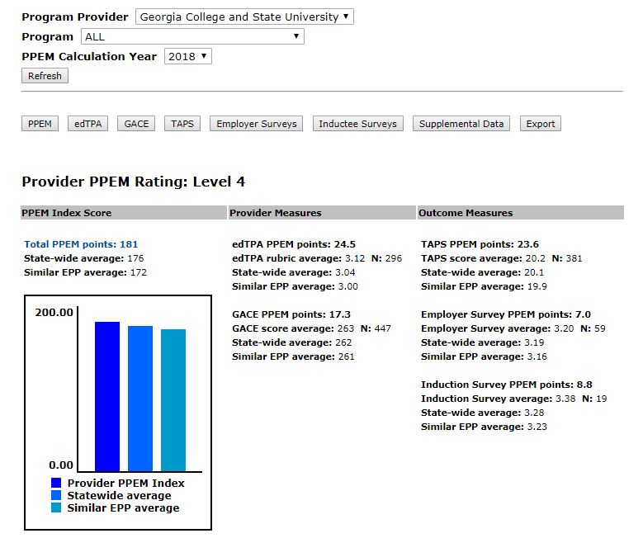

Standard 19
We use a field-based cohort model that ensures rigor and mastery (see: http://www.gcsu.edu/education/cohorthistory)

