Secondary Education Master of Arts Program

We also have EDFS 6501 Secondary Social Studies Pedagogy, EDFS 6507 Secondary Science Pedagogy, and EDFS 6502 Content Pedagogy and will include these files.

Standard 1
Selection Criteria
- Fall 2018 Georgia College and State University mean SAT is 1211
- Fall 2018 Georgia College and State University mean ACT is 25
- Fall 2018 Georgia College and State University mean GRE verbal is 150, GRE quantitative is 148 and GRE analytical writing is 3.7
- Average graduate secondary education MAT GPA is 3.3
- We are seeking CAEP accreditation so all students need to have a minimum GPA of 3.0.

Standard 7
- By Georgia Professional Standards Commission (PSC) rule, All secondary science students must pass the GACE content examination for each area for which they receive certification (see: https://www.gapsc.com/Rules/Current/EducatorPreparation/505-3-.29.pdf for content requirements and https://www.gapsc.com/Rules/Current/Certification/505-2-.26.pdf for the GACE requirement rule).

Standard 8
- By Georgia Professional Standards Commission (PSC) rule, All secondary social science students must pass the GACE content examination for each area for which they receive certification (see: https://www.gapsc.com/Rules/Current/EducatorPreparation/505-3-.23.pdf, https://www.gapsc.com/Rules/Current/EducatorPreparation/505-3-.25.pdf, https://www.gapsc.com/Rules/Current/EducatorPreparation/505-3-.26.pdf, & https://www.gapsc.com/Rules/Current/EducatorPreparation/505-3-.28.pdf for content requirements and https://www.gapsc.com/Rules/Current/Certification/505-2-.26.pdf for the GACE requirement rule).

Standard 10
- For Standard 10, classroom management is infused throughout the program and formally observed at least 5 times.
- Management is stressed in EDFS 5213 Instructional Strategies.

Standard 11
- All students take EDFS 5213 Instructional Strategies, EDFS 5205 Planning for Instruction, EDFS 5215 Content Assessment, EDFS 5209 Learner Differences, EDFS 5202 Learner Development, and EDIT 5202 Technology for Teachers to meet this standard.

Standard 12
- All students take EDFS 5215 Content Assessment to meet this standard.

Standard 13
- Students are placed in a variety of schools in accordance with the PSC.
- Several districts in our area are 100% free and reduced lunch districts, including Baldwin County Georgia where we are located and place many students.

Standard 14
- All students take EDFS 6466 Student Teaching and are formally observed at least 5 times.
- According to PSC rule (see: https://www.gapsc.com/Rules/Current/EducatorPreparation/505-3-.01.pdf), “B/P-12 supervisors shall have a minimum of three (3) years of experience in a teaching, service, or leadership role; and (II) If the residency or internship is completed at a Georgia school requiring GaPSC certification, the B/P-12 supervisor shall hold renewable Professional Level Certification in the content area of the certification sought by the candidate.”
- Additionally we must have a partnership agreement with any school where students are placed ("The Partnership Agreement shall also include a principal or employer attestation assuring educators selected for supervision of residencies/internships are the best qualified and have received an annual summative performance evaluation rating of proficient/satisfactory or higher for the most recent year of experience. (See: https://www.gapsc.com/Rules/Current/EducatorPreparation/505-3-.01.pdf).

Standard 15
- EDFS 6501 Secondary Social Studies Pedagogy
- EDFS 6507 Secondary Science Pedagogy
- EDFS 6502 Secondary Mathematics Pedagogy
- EDFS 6503 Communicative Literacies (English/Language Arts) Pedagogy
- EDFS 6502 Content Pedagogy (Business Education/Art/World Language) – individualized course that includes differentiated assignments per content area.

Standard 17
- All students are required to complete an exit survey for the institution consistent with CAEP standard 5.5 (The provider assures that appropriate stakeholders, including alumni, employers, practitioners, school and community partners, and others defined by the provider, are involved in program evaluation, improvement, and identification of models of excellence.)
- A survey is also sent out to employers.
- The PSC also has a survey available to graduates.
- Each year we have an assessment retreat to review all data for program improvement.
- We have a Professional Education Stakeholders Council to get input from all stakeholders on our programs.

Standard 18
- The PSC will be making our dashboard public in the format below. This year it was not made public.
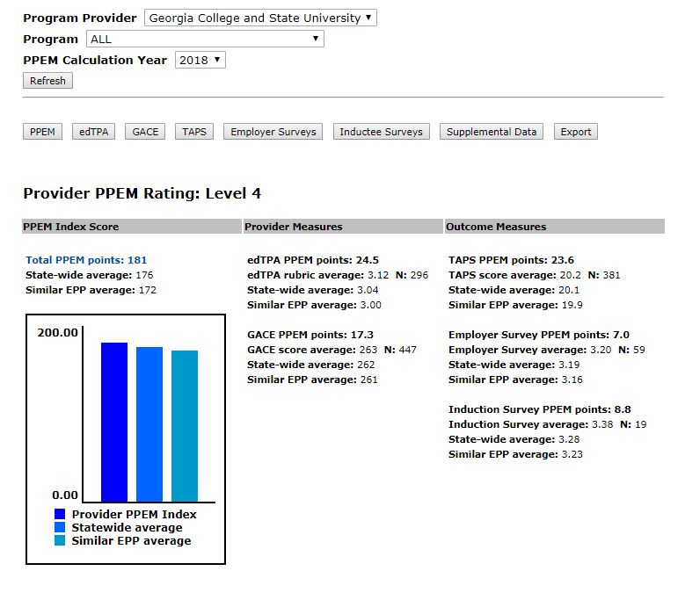

Standard 19
We use a field-based cohort model that ensures rigor and mastery (see: http://www.gcsu.edu/education/cohorthistory)

