August 1, 2018

Dear Dancers and Parents,

This is your information letter about ordering Nutcracker costumes. Please make all checks out to GCSU. Money and order forms are due: Friday, September 14!!!! Fill out one order form per costume. Do not put all of the costumes on one order form! Remember to order a size up so that they may be worn in the spring concert in May!! (Creative Movement will have a different costume in the spring concert). Please order UP if in any doubt!! Pictures of the costumes are on the bulletin boards by the dance studios. You may call the registration office at (478) 445-5277 and put them on a credit card, but you must still fill out an order form! Do not combine tuition and costume orders! Please make out separate checks. There are size charts by the pictures as well.

The cast list will be posted at both Milledgeville dance studios very soon.

Nutcracker Costumes 2018

Creative Movement - “Baby Mice” - gray mouse costume - $60.00, sizes: child small, medium, and large. The costume runs big! All creative movement students should order a child small! Pink tights, pink ballet shoes for girls. Black ballet shoes for boys. Everyone will need a black tank leotard to wear underneath. We will make pink ears and draw on whiskers. This costume comes with a mouse hat and mittens. We are not using those in the show, so the students can play with them at home.

Adult/Teen Beginning Ballet - “Adult Mice” - see costume above for Creative Movement.
Cost: $65.00. Sizes: Adult small, med., lg. Pink tights, pink ballet shoes, black camisole leotard underneath.

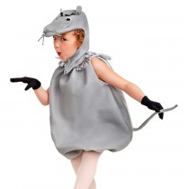

Ballet I - “Angels” - White dance tutu with angel wings and halo.
$55.00. Sizes: XS child (2-3), Small (4-6), Intermediate (6X-7), Medium (8-10), and Large (12-
14), XL - $60.00. does not come in adult sizes, pink tights, pink ballet shoes,

2. angel wing kit which includes wings and a halo - $17.00.

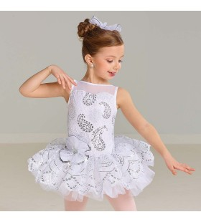

Ballet II - “Pollichinelles” – sizes: child S, M, lg., $55.00 CXL adult sizes: small, medium, large: $65.00, pink tights, pink ballet shoes. In purple.

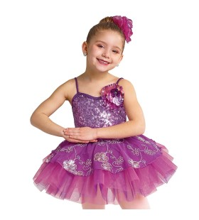

Soloist for “Pollichinelles” – Pink Tutu, we have this.

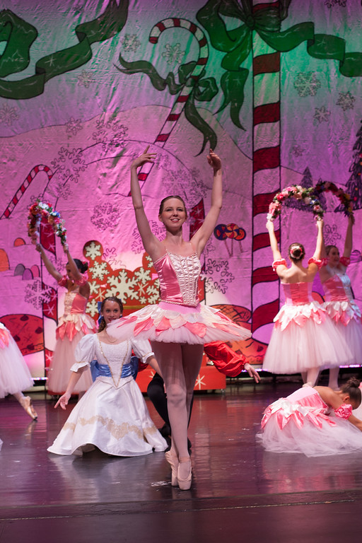

Ballet III – “Gum Drops” Sizes: child: XS - CXL - $55.00, and adult sizes of CXL, $60.00. pink tights, pink ballet shoes. Royal blue.

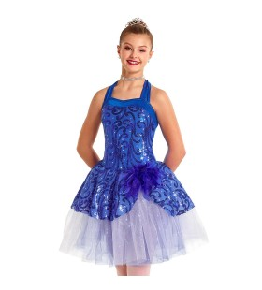
Ballet III soloist – Adult S,M,L $75.00, in Red.

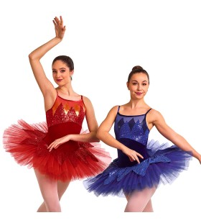

Ballet IV “ ”– Child: small, medium, large - $55.00, Child X large, adult small, medium, large - $60.00, adult extra large: $65.00, pink tights and ballet shoes or pointe shoes. 2XL, 3XL - $70.00. We already have white muffs. No black gloves.
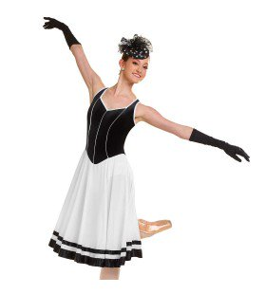

Soloist for Ballet IV – tutu in sizes AS-L, $75.00. No gloves.

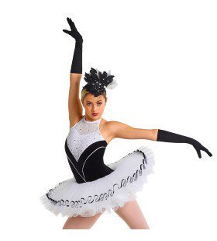

Ballet V – “Christmas Belles” Child Small – Adult Large - $65.00, CXL,Adult XL - $70.00, Adult XL - $75.00, 2XL, 3XL - $80.00. Red. Pink tights, pink ballet shoes, pointe shoes.

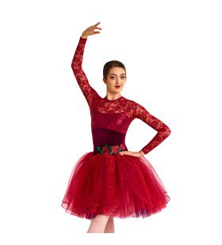

Ballet V soloist Adult S – L, $70.00 In Blue

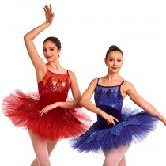

Ballet VI - “Waltz of the Flowers” –Velvet bodices, Child X small – child large - $65.00, Child X large – Adult large - $70.00, Adult X large - $76.00, 2XL, 3XL - $80.00, pink tights, pink ballet shoes or pointe shoes. ½ of the class in burgundy, ½ of the class in sapphire blue

Dew Drop Fairy

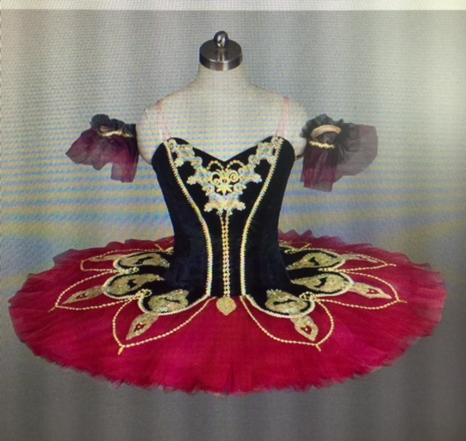

Spanish and soloist - We will use the ones we already have, shown below. Tan tights, tan character shoes.

Kingdom of Sweet dancers – will wear the costume from their solo/class

Dream Fairies – long white romantic length tutus (we have them), pointe shoes, wands and wings (we have these)

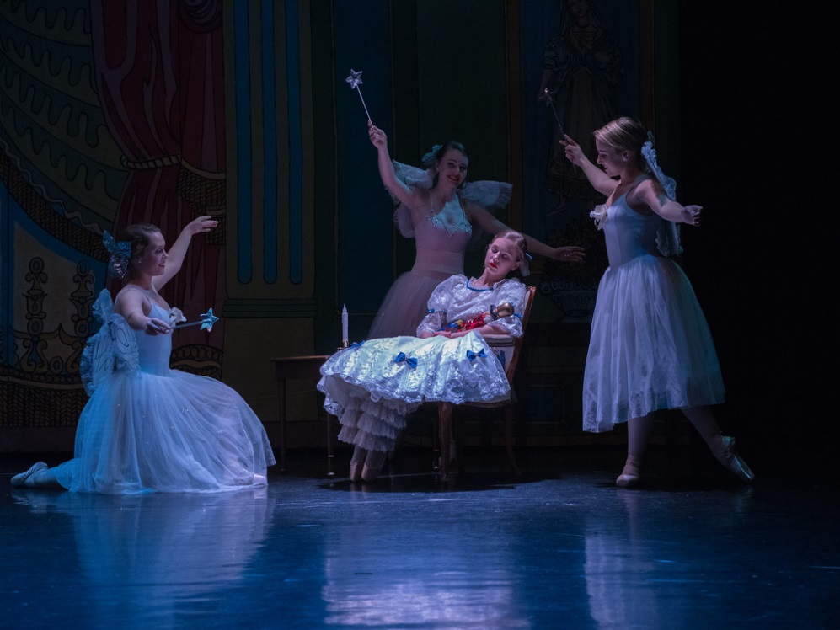

Dream Fairy Soloist, we have this. Pale Pink.

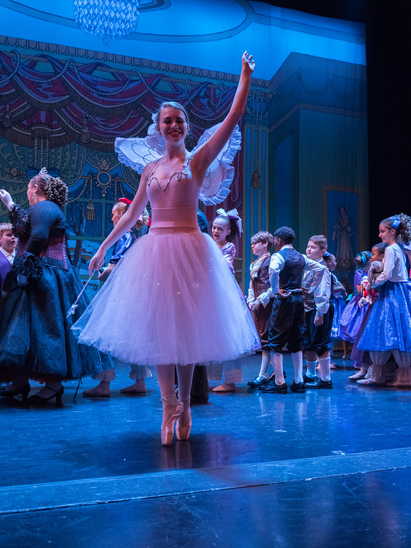

Chinese dancers – (we have these) we will use these from last year, black leggings, pink tights, gold fans, pointe shoes/ballet shoes.

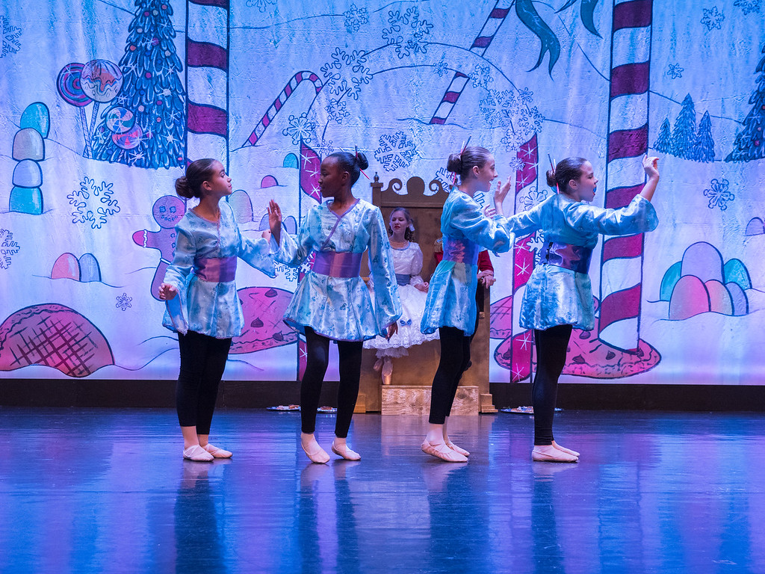

Japanese dancers – Hot pink tutus, (we have these), pink tights, pointe shoes, parasols

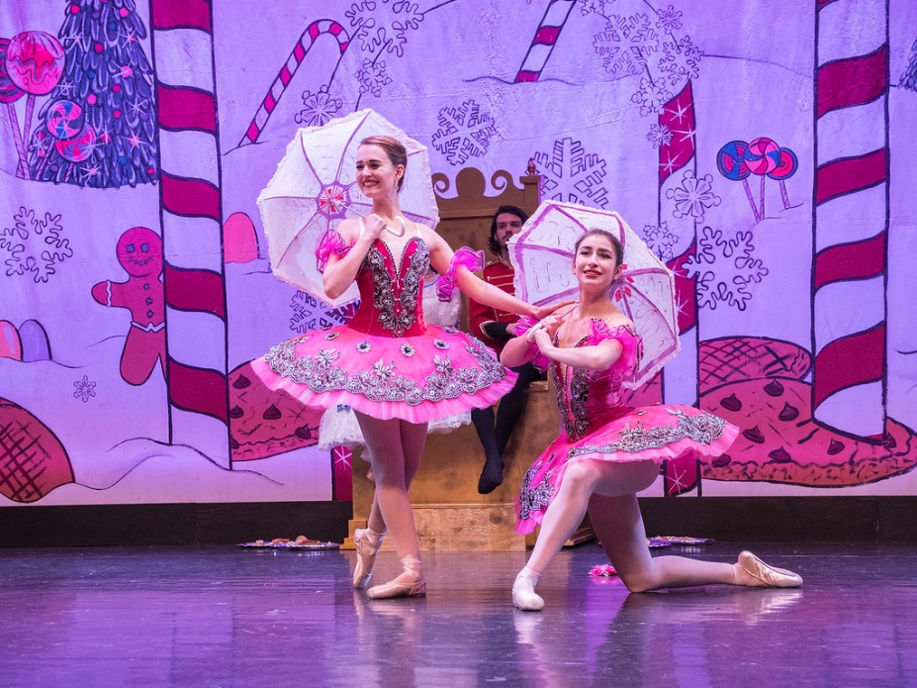

Ballet VII - Snowflakes and Snow Queen- white tutu and matching bodice – 1. bodice: Sizes: Adult: 8A, 10A, 12A, 14A - $70.00, 16 adult $75.00, 2. tutu sizes: Adult 8, 10, 12, 14 $141.00, 16 adult $146.00, 16A - $133.00, pink tights and pointe shoes, 3. sparkle fur trim for bodice and hair - $3.00. (These costumes run VERY small and DO NOT STRETCH!!! check size chart before ordering!)

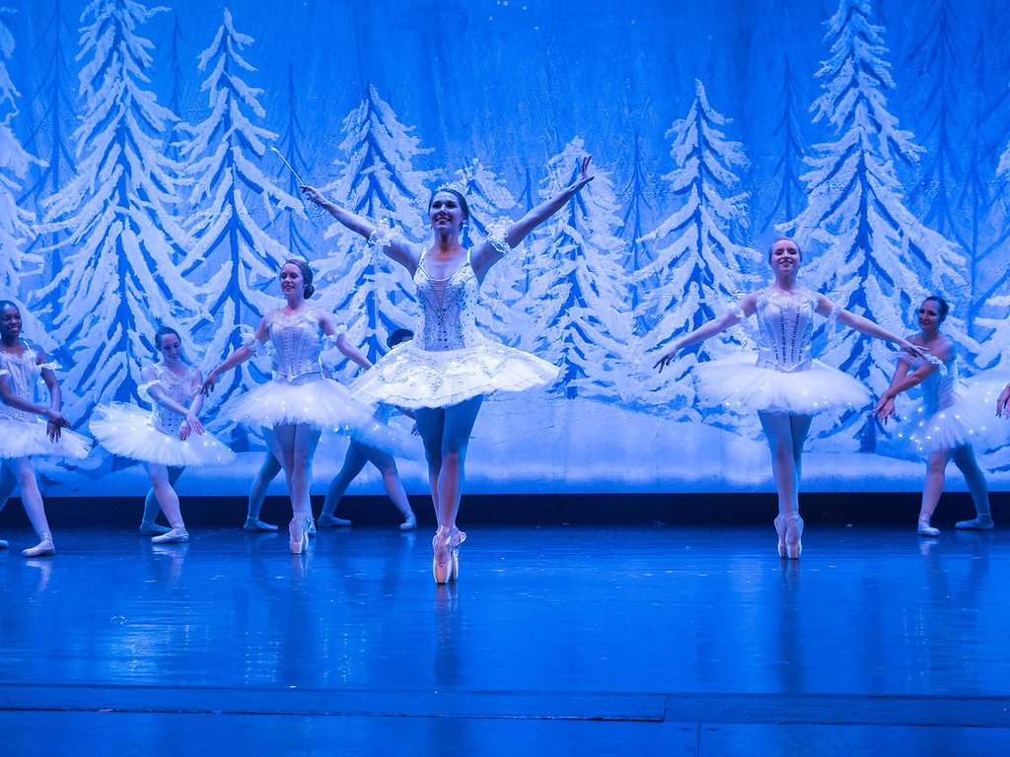

Baby Dolls – Red velvet tutus and Green long tutus that we already have. Pink tights and pointe shoes or ballet shoes.

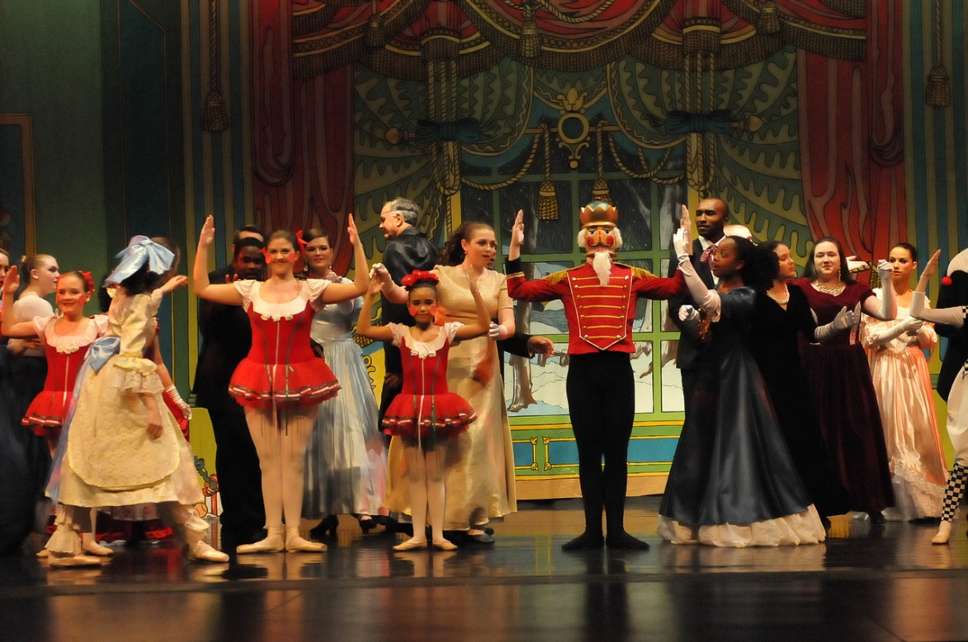
Harlequin Dolls - We already have these.

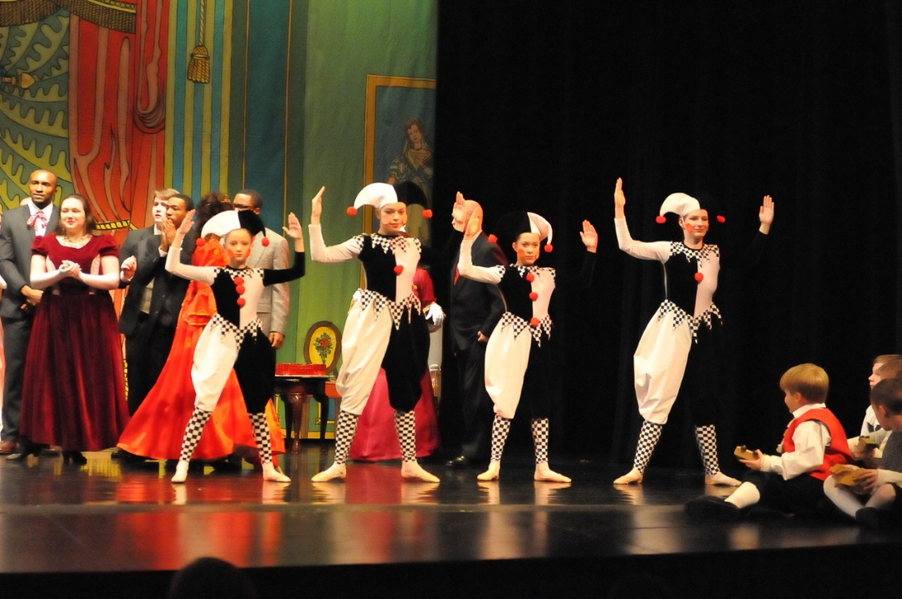

The Nutcracker – We have this. See picture above.

Bon Bons – tutu: sizes: Child: Xsmall, small, medium, large - $50.00, Child XL - $55.00, pink tights and ballet shoes.

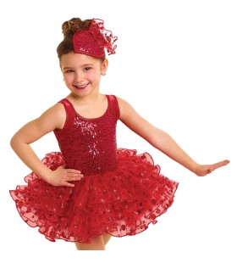

Arabians - turquoise chiffon pants - $30.00, one size only, bra-dancers purchase and decorate, gold jewelry.
Arabian Soloist – red costume, GC has bottoms and accessories, Dancer purchases red bra to decorate

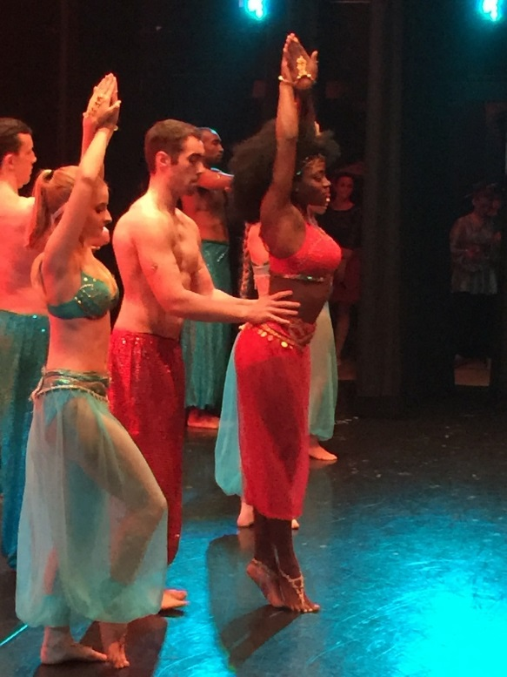

Indian dancers – Same dress as last year, child medium – Adult large - $67.00, Child XL, Adult X large - $76.00, AXL - $80.00, 2XL,3XL - $85.00, tan lights, ballet shoes

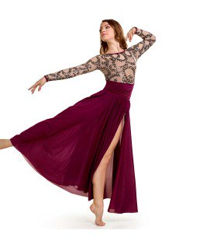

All Tap classes - “Soldiers” - you buy solid black knit pants for girls, black jeans or pants for boys, black socks, red turtle neck shirt (Walmart) worn on the outside, black tap shoes. Hot glue gold epalettes on shoulders- $20.00, hat and sword - we will provide.

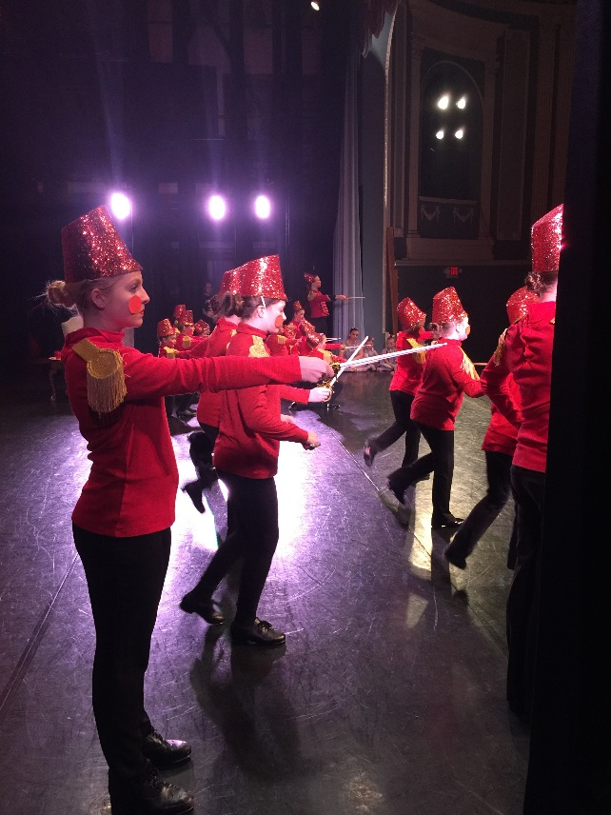

Candy Canes - Red and white striped unitard from last year with red tutu and pointe shoes. We have these.

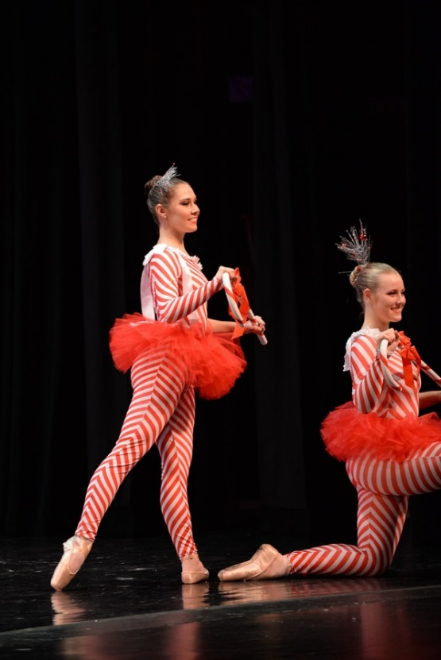

Lamb chops – same costumes as last year, we have them

Bo Peep – we have the costume, see below
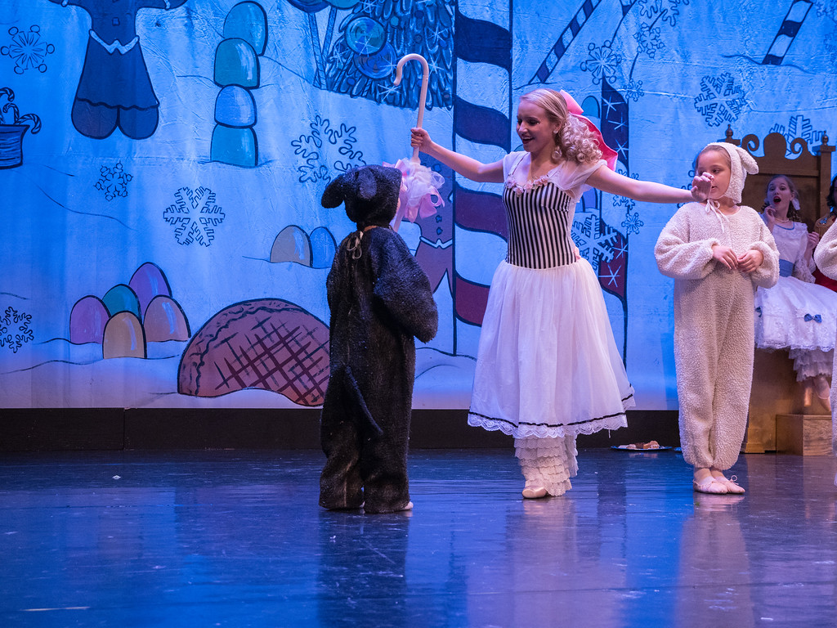
Dancing Reindeer – we have these
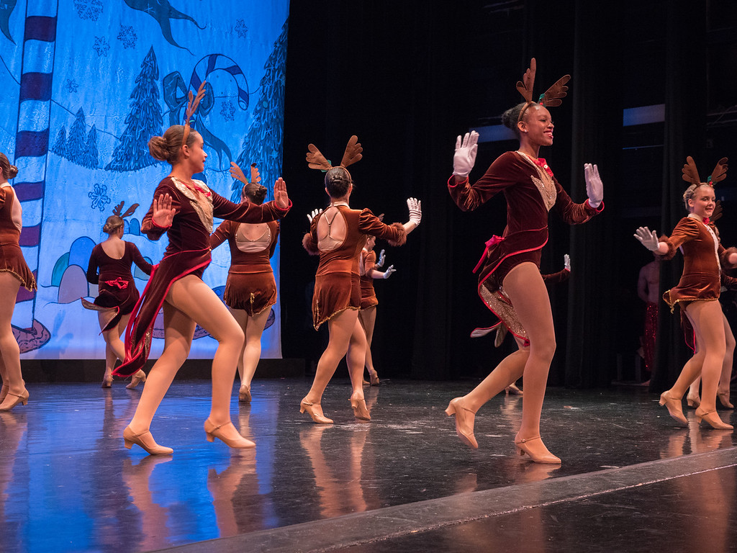

Trumpeteers: we have these

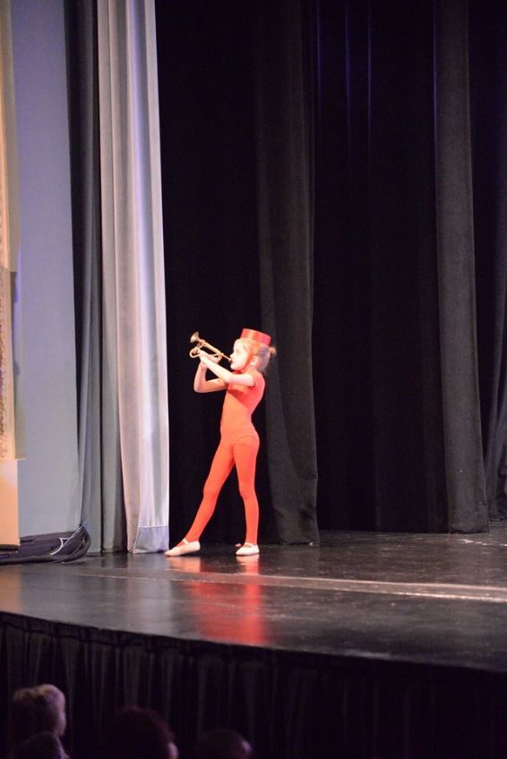
Reindeer that pull the sleigh: we have these. Dancers need ballet shoes, tan tights.
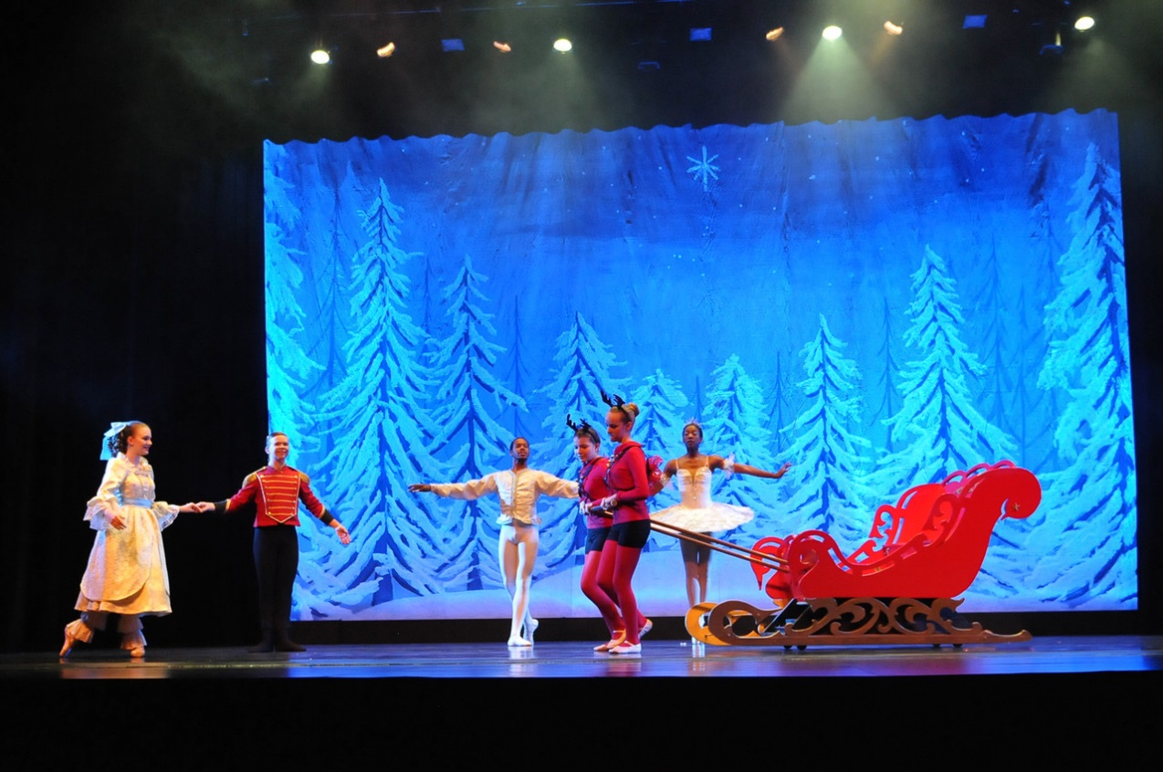
Adults, Teens, Children in party scene - adults: ladies will need a long 1880’s style dress, no hoop skirt as it will get in the way, dress must have sleeves, fancy jewelry, hair pieces are needed, hair ornaments, fans, black character shoes, wrap if you are not the host family. We have the petticoats and pantaloons , men: dark suit, white shirt, we have string ties, black shoes and socks, we have the vests! children: girls need a brightly colored SOLID dress to the calf, fancy in design, no pastel colors! ( we will chose colors at first meeting of parents on rehearsal schedule), ecru lacy pantaloons, pink tights, pink ballet shoes, old fashioned rag doll, hair bow, wrap if you are not the host family, boys: knickers (long pants rolled under) in a fancy fabric (velvet, corduroy) , vest in a print or solid, ecru shirt with lace at cuffs and color, (from ladies department), white knee socks (from girl’s department), Sunday shoes that tie. EVERYTHING must look old-fashioned - no modern day dresses!!!! ALL DRESSES MUST HAVE A SHORT OR LONG SLEEVE – NO SLEEVELESS DRESSES!!!!

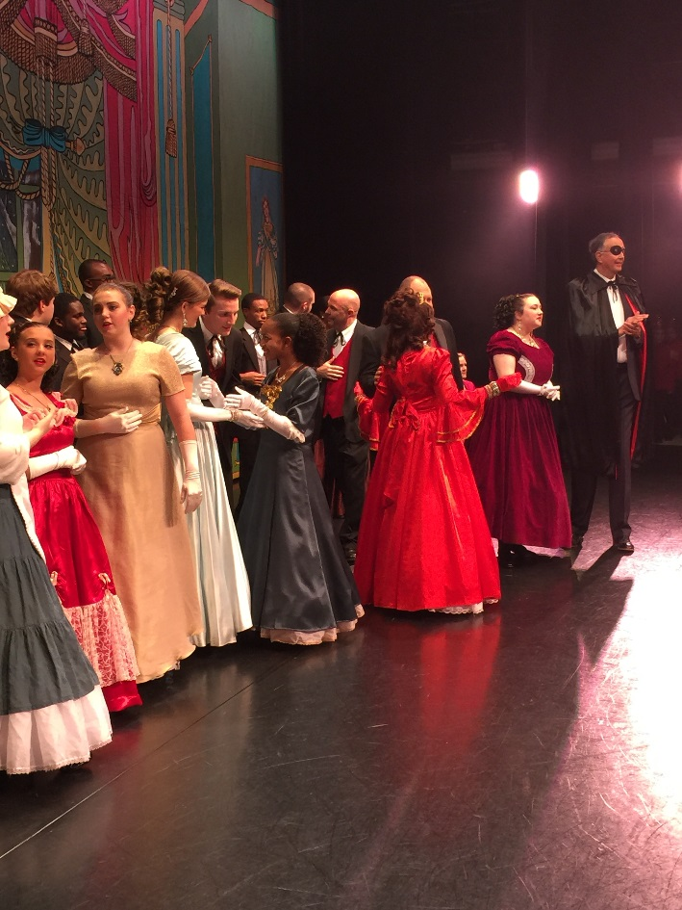

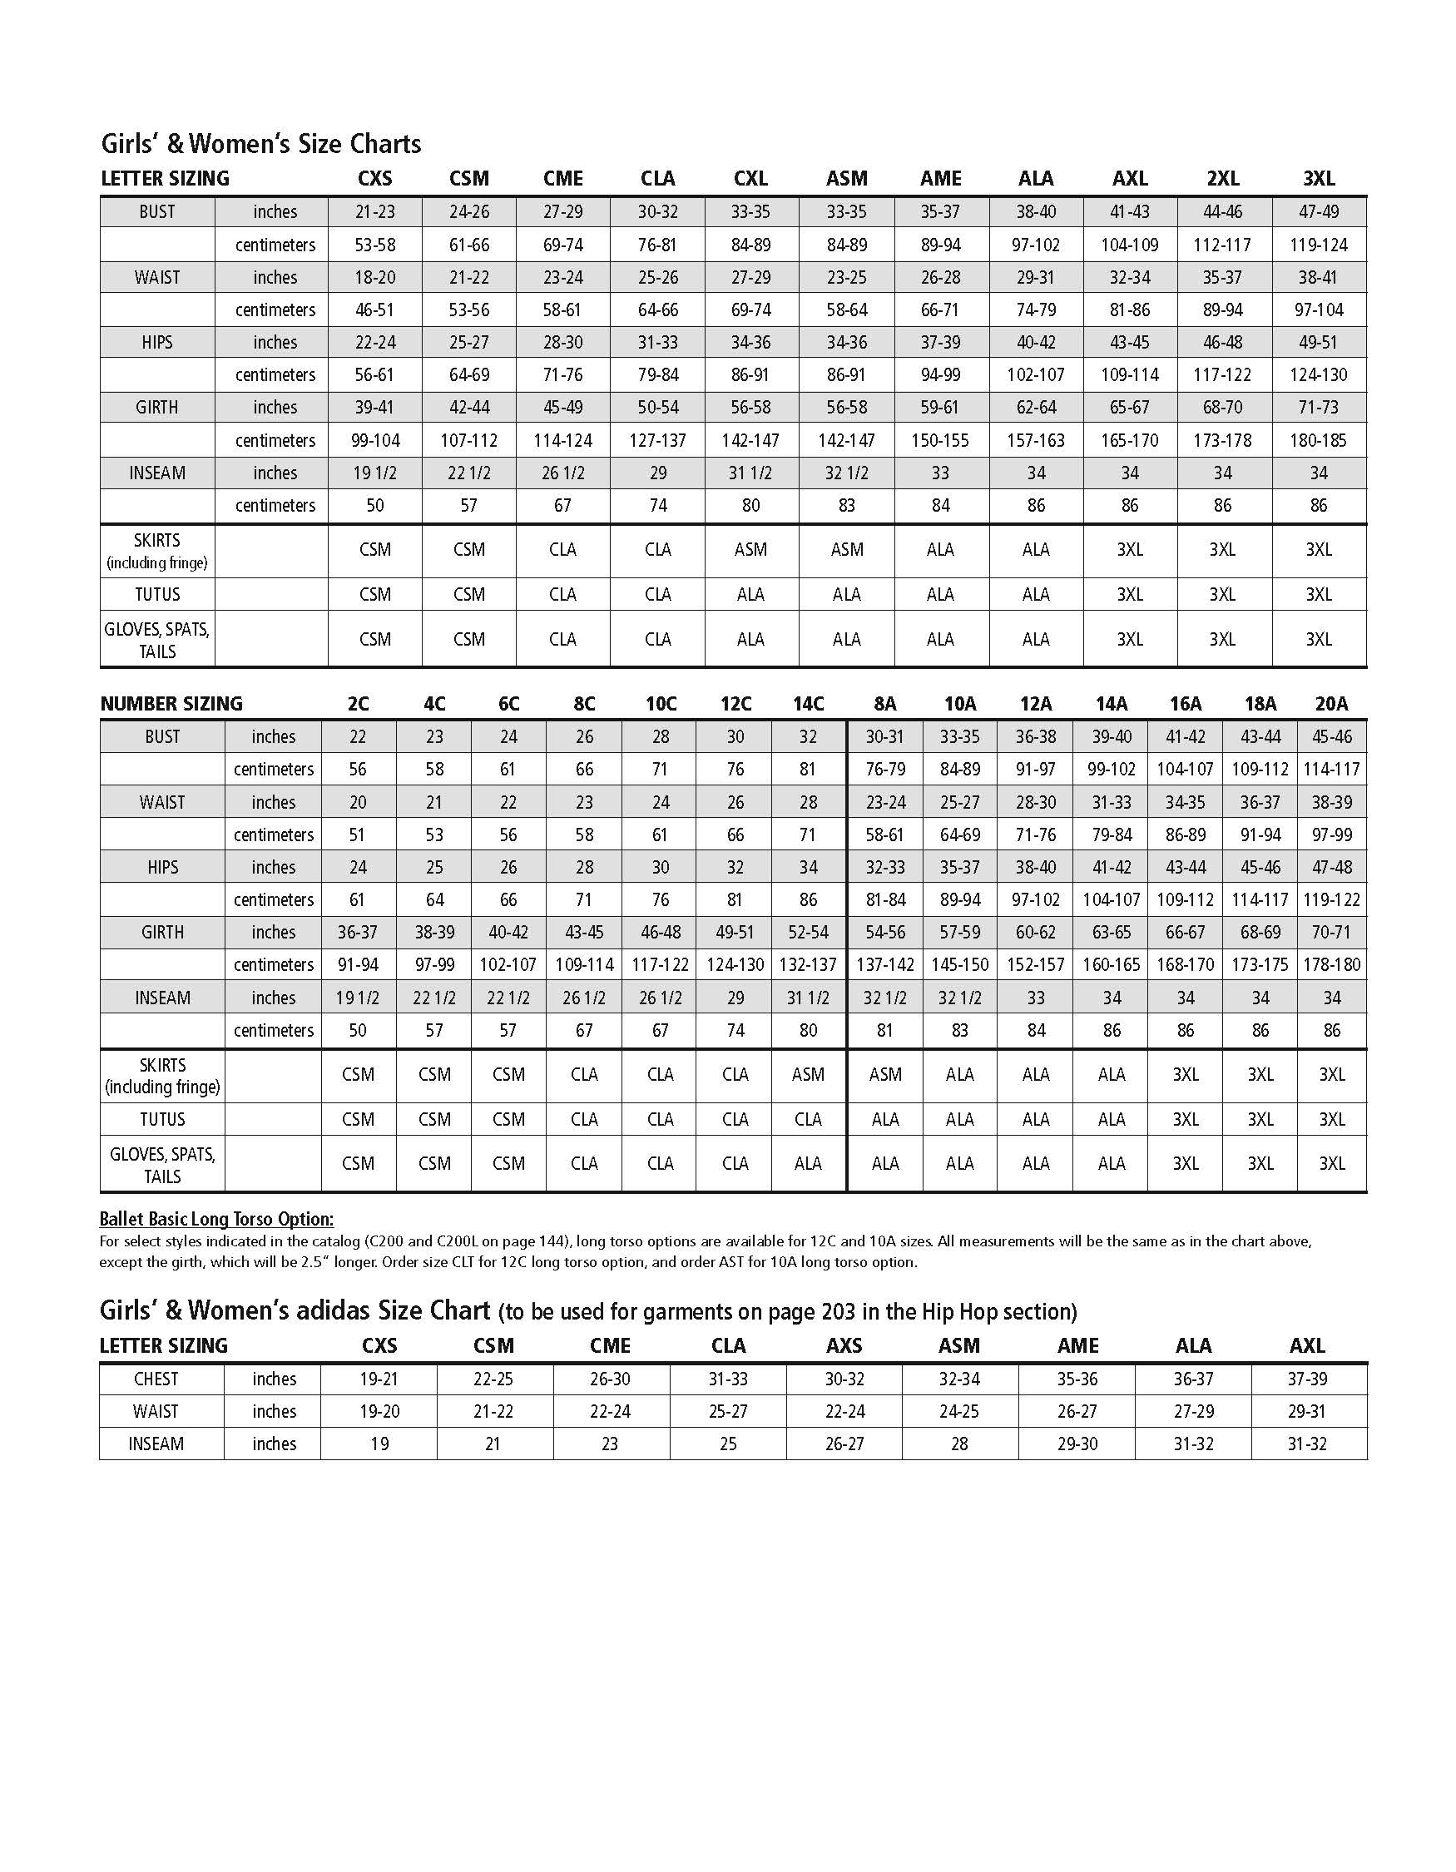

Nutcracker Costume Order Form 2018

All money for costumes are due September 14!!!! Make checks out to: GCSU, Please don’t include tuition!! Questions? E mail Amelia at amelia.pelton@gcsu.edu or Natalie King at Natalie.king@gcsu.edu

Only one costume per order form please!!!

Name

Class for this costume

Phone Email

Size
ordered: price:

Accessories
needed: price

price

total

Remember to order a size up!! Costumes will be worn again in the spring concert (Except Creative movement)!

Check size charts! Do not rely on Amelia or the instructor to tell you what size to order! You are responsible for the size you order for your dancer.

Make checks out to: GCSU. Call or visit the Continuing and Professional Education office to put it on a credit card. (478)445 – 5277. All order forms and money are due: September 14!

Use a separate order form for each costume please!

