FEATHER | FRUIT | STICK | FUNGUS | MUSHROOM
ANT | BUTTERFLY | BEETLE | SPIDER | REPTILE
LICHEN | ANIMAL  TRACKS | 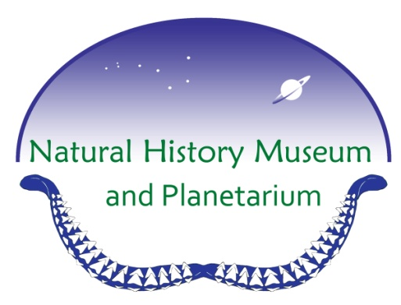 | MOSQUITO | MOSS
FROG | ROCK | CREEK | ACORN | TREE  BARK
BEE | CLOUD | FLOWER | GRASS | BONE

Forest Hike BINGO

PINE CONE | BEETLE | GRASS | LEAF | FERN
BERRY | ROCK | ACORN | BEE | LICHEN
CREEK | FLOWER |  | MOSS | FROG
SPIDER | FEATHER | STICK | ANT | MUSHROOM
POOP | REPTILE | MOSQUITO | BONE | FUNGUS

Forest Hike BINGO

FLOWER | FERN | ANIMAL  TRACKS | CREEK | ROCK
FERN | BUTTERFLY | BEETLE | FEATHER | LEAF
PINE  CONE | BERRY |  | POOP | ANT
MUSHROOM | SPIDER | CLOUD | LICHEN | FROG
GRASS | FRUIT | ACORN | BEE | TREE BARK

Forest Hike BINGO

