FROG | FISH | TURTLE | POND PLANT | ALGAE
GRASS | STONE | WATER INSECT | MOSQUITO | WATER SPIDER
DUCK | HERON | 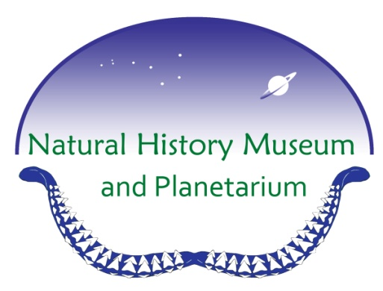 | MOSS | CLOUD
TADPOLE | TRASH | LILY PAD | FEATHER | STICK
LOG | CREEK | FLOWER | SEED | FILTER

Pond Hike BINGO

DRAGON  FLY | FEATHER | LOG | ALGAE | HERON
GRASS | FISH | LILY PAD | WATER INSECT | STONE
TRASH | FLOWER |  | DUCK | TURTLE
WATER  SPIDER | CREEK | TADPOLE | FILTER | STICK
STICK | POND PLANT | MOSQUITO | CLOUD | FROG

Pond Hike BINGO

FLOWER | DRAGON  FLY | FROG | CREEK | FILTER
FISH | SEED | TURTLE | FEATHER | POND PLANT
LOG | ALGAE |  | STICK | GRASS
LILY PAD | WATER  SPIDER | CLOUD | TRASH | TADPOLE
DUCK | HERON | MOSQUITO | MOSS | STONE

Pond Hike BINGO

