PINE  NEEDLE | BERRY | REPTILE | BONE | FERN
POOP | PIECE OF METAL | PINE CONE | BUTTERFLY | FLOWER
FROG | CLOUD | 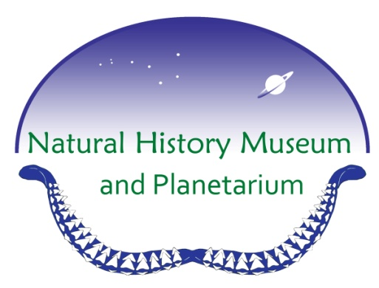 | LEAF | ANIMAL  TRACKS
PLASTIC  BOTTLE | BEETLE | TREE BARK | CREEK | PIECE OF  GLASS
MOSS | LICHEN | SPIDER | BIRD | MOSQUITO

Trail Hike BINGO

STICK | FEATHER | ROCK | BOTTLE  CAP | FRUIT
ACORN | PINE NEEDLE | BONE | MOSS | BOTTLE CAP
PLASTIC  BOTTLE | FLOWER |  | BIRD | BERRY
SPIDER | CREEK | BEETLE | REPTILE | POOP
LEAF | LICHEN | MOSQUITO | FERN | PIECE OF  METAL

Trail Hike BINGO

FLOWER | FERN | PINE NEEDLE | CREEK | ROCK
BERRY | BUTTERFLY | BEETLE | FEATHER | LEAF
REPTILE | BERRY |  | POOP | BONE
PIECE OF  METAL | SPIDER | CLOUD | LICHEN | FROG
PIECE OF  GLASS | FRUIT | ACORN | MOSS | BIRD

Trail Hike BINGO

