Have you ever been without electricity? It’s difficult to imagine life without it, but to the Governors who lived in the Mansion, they couldn‘t imagine life with it!
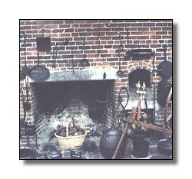
The original kitchen used a hearth with open fire to heat coals which were used to prepare food. These coals were also used to heat the beehive oven for baking. What things do you have in your kitchen that you do not see here?
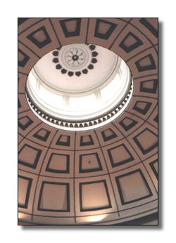
The cupola is at the top of the rotunda. In summer the windows were raised so cooler air could circulate throughout the house. What do we have to keep our houses cool today?
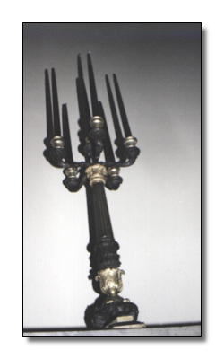
Candles or oil lamps were the only source of light during the evening hours. You will see many candelabrum (candle holder) as you tour each room.

