High Achievers

Program Goals

* To provide apprenticeship and project-based learning.
* To help youth develop, learn, and apply the civic skills of organizing, communicating, and working with others in their community and country.
* To value civic efficacy where students understand their capacity to be change agents among their peers, throughout their community and among the global society.



Georgia Achievers



high_achievers_gc

Contact Information

**Mailing Address:**

Georgia College High Achievers Program

231 West Hancock Street

CBX 075

Milledgeville, Georgia 31061

**Located At:**

Georgia College

Office Location: 203 Chappell Hall

Building Location: 211 N. Clarke Street

Milledgeville, Georgia 31061

Staff Members

Sequena Moon, Ed. S

Director, Afterschool Acheivement

Phone: 478-445-5613

Email: sequena.moon@gcsu.edu

Deaje Taylor

Program Coordinator

Phone: 478-445-8509

Email: deaje.taylor@gcsu.edu

Group Leaders: GCSU College Students

Enrichment Instructor: Kerri Pompey

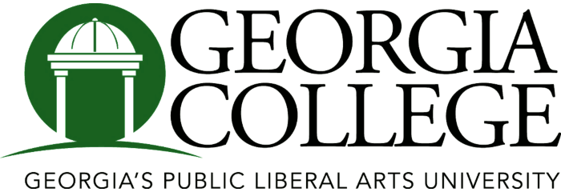

What

I

Need

To

Know

About

The

High

Achievers

Program…

What is the High Achievers

Program?

The High Achievers Program is an afterschool youth development program designed to help young people reach their full potential and have a solid base for learning and growing. By participating in diverse and comprehensive educational programming, leadership development/enrichment activities that include a summer employment focused youth apprenticeship program, youth are encouraged to become effective and participatory future leaders.

During the academic year, funding supports students from grades nine through twelve, with weekly leadership enrichment programming 4 to 5 days per week.

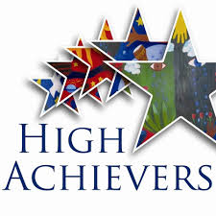

Mission

The mission of the High Achievers Program exists to prepare future leaders. The Program believes that every young person has the potential to become a community leader. By participating in high-quality educational programming and enrichment activities, youth are encouraged to become effective and participatory future leaders.

The program fosters leadership development through exposure to STEAM based activities, enrichment field trips, college tours and summer apprenticeship-based learning initiatives thus preparing well-rounded individuals.

Objective

We see every youth in the program as "at promise" and none "at risk." We see the worth of every child and recognize every parent as a competent provider. We aim to help youth discover new talents and competencies. The High Achievers Program provides services that every parent would want for his/her child but sometimes cannot afford to provide.

Funding



The High Achievers Program is funded by the GA Department of Human Services and is a partnership between Georgia College, Baldwin Co. Board of Education and the Milledgeville community.

Components

Health Education & Physical Activity

Youth participate in hands on learning activities that support positive mental health such as healthy lifestyles, teen violence, and suicide prevention. To support physical health, participants also engage in physical activity each week using GA Shape Initiatives.

Youth Voice & Action

YVA helps participants to learn the proper ways to respond to obstacles & techniques to work through life’s challenges thereby expanding their critical thinking abilities. It includes leadership training, group sessions & service learning activities within the community.

Well-being

Youth participate in a violence and injury prevention & substance abuse component which are geared towards learning the skills necessary to reduce and/or eliminate their chances or engaging in unhealthy life decisions.

STEAM

Participants engage in project-based learning activities to become well-rounded, disciplined learners of STEAM-Science, Technology, Engineering, Art, and Math. Participants then replicate and implement STEAM initiatives to elementary aged youth during their summer apprenticeship program.

Apprenticeship Program – Summer

Youth participate in apprenticeship-based learning throughout the academic year to better prepare them to become summer camp counselors during a 4 week summer camp program where they will design, coordinate, and facilitate a youth camp program.